**VISVESVARAYA TECHNOLOGICAL UNIVERSITY**

**“Jnanasangama”, Belagavi-590018, Karnataka**



**BANGALORE INSTITUTE OF TECHNOLOGY**

**K.R. Road, V.V.Puram, Bengaluru-560 004**



**DEPARTMENT OF COMPUTER SCIENCE & ENGINEERING**

**DATABASE MANAGEMENT SYSTEM MINI PROJECT**

**18CSL58**

**“COVID-19 MANAGEMENT SYSTEM”**

**Submitted By**

**Likitha K**

**1BI18CS074**

**for the academic year 2020-21**

**Department of Computer Science & Engineering**

**Bangalore Institute of Technology**

**K.R. Road, V.V.Puram, Bengaluru -560 004**

**VISVESVARAYA TECHNOLOGICAL UNIVERSITY**

**“Jnanasangama”, Belagavi-590018, Karnataka**

**BANGALORE INSTITUTE OF TECHNOLOGY**

**K.R. Road, V.V.Puram,** **Bengaluru -560 004**



**Department of Computer Science & Engineering**

***Certificate***

This is to certify that the implementation of **DBMS MINI PROJECT** entitled   
“**COVID-19 MANAGEMENT SYSTEM**” has been successfully completed by

**USN:1BI18CS074 NAME :Likitha K**

of V semester B.E. for the partial fulfillment of the requirements for the Bachelor's degree in Computer Science & Engineering of the Visvesvaraya Technological University during the academic year 2020-2021.

**Lab Incharges :**

Prof. Prathima M G **Dr.Asha T**

Assistant Professor Professor and Head

Dept. of CS&E Department of CS&E

Bangalore Institute of Technology Bangalore Institute of Technology

Bengaluru Bengaluru

Prof Mahalakshmi C V

Assistant Professor

Dept. of CS&E

Bangalore Institute of Technology

Bengaluru

Examiners: 1) 2)

**ACKNOWLEDGEMENT**

I would like to express my sincere gratitude towards several individuals and my university for supporting me in successfully completing this Mini Project.

First I would like to convey my thanks to the Head of the Department **Dr.ASHA.T** for offering us the opportunity to work on this Mini Project.

I would like to express my sincere gratitude to my Lab In-charges **Prof. PRATHIMA M.G** and **Prof. MAHALAKSHMI C.V** for their enthusiasm, patience and insightful comments, helpful information, practical advice and unceasing ideas that have helped me tremendously at all times in my project.

I would like to take this opportunity to also thank my friends and family for their constant support for the successful completion of this project.

I am also grateful for the staff of Computer Science Department for their cooperation towards the completion of this project .Thank you all for the encouragement.

**Likitha K**

**1BI18CS074**

**Contents**

|  |  |  |  |
| --- | --- | --- | --- |
| **1.** |  | **Introduction** | 1-1 |
| **1.1** | Introduction | 1 |
| **2.** |  | **Back end Design** | 2-11 |
| **2.1** | Conceptual Design | 2 |
| **2.2** | Logical Design | 3 |
| **2.3** | Normalization | 4-11 |
| **3.** |  | **Front End design** | 11-14 |
| **3.1** | Screen Layout Design | 12 |
| **3.2** | Front end technology | 13 |
| **3.3** | Connectivity | 13-14 |
| **4** |  | **Major Modules** | 15-17 |
| **4.1** | Citizen Module | 15 |
| **4.2** | Hospital Module | 15-16 |
| **4.3** | Doctor Module | 16 |
| **4.4** | Team Module | 16 |
| **4.5** | Admin Module | 17 |
| **5** |  | **Implementation** | 18-32 |
|  | **5.1** | Create Tables | 18-20 |
| **5.2** | Java Controllers | 21-22 |
| **5.3** | View | 23-32 |
| **6** |  | **Snapshots** | 33-57 |
| **6.1** | Screenshots | 33-55 |
| **6.2** | Test cases | 56-57 |
| **7** |  | **Application** | 58 |
| **7.1** | Applications | 58 |
| **8** |  | **Conclusion** | 59 |
| **8.1** | Conclusion | 59 |

**Figures**

|  |  |  |  |
| --- | --- | --- | --- |
| **2.** | **2.1.1** | ER Diagram for COVID-19 application | 2 |
| **2.2.1** | Relational Mapping | 4 |
| **2.3.1** | Dependency Graph | 6 |
| **3.** | **3.1.1** | General Screen layout | 12 |
| **6** | **6.1.1** | Home page | 33 |
| **6.1.2** | User Login Portal | 33 |
| **6.1.3** | View Hospitals in Locality | 34 |
| **6.1.4** | List Of hospitals in locality | 34 |
| **6.1.5** | View cases in locality | 35 |
| **6.1.6** | List of nearby cases in locality | 35 |
| **6.1.7** | Total cases in India | 36 |
| **6.1.8** | Number of cases in India | 36 |
| **6.1.9** | Portal for foreign visit form | 37 |
| **6.1.10** | Foreign visit form details | 37 |
| **6.1.11** | Welcome to Foreign Data Controller | 38 |
| **6.1.12** | Update details | 38 |
|  | **6.1.13** | Update details form | 39 |
| **6.1.14** | View new patient list | 39 |
| **6.1.15** | Assigning doctor to new patient | 40 |
| **6.1.16** | View complete list of patients | 40 |
| **6.1.17** | Complete list of patients | 41 |
| **6.1.18** | View particular patient info | 41 |
| **6.1.19** | Individual Patient info | 42 |
| **6.1.20** | View list of doctors | 42 |
| **6.1.21** | List of Doctor with details | 43 |
| **6.1.22** | Add a doctor | 43 |
| **6.1.23** | Provide details of doctor | 44 |
| **6.1.24** | New doctor added | 44 |
| **6.1.25** | Add hospital | 45 |
| **6.1.26** | Enter details of hospital | 45 |
| **6.1.27** | Hospital details entered successfully | 46 |
| **6.1.28** | Add patients | 46 |
| **6.1.29** | Enter details of patient | 47 |
|  | **6.1.30** | Patient details entered successfully | 47 |
| **6.1.31** | View patient list | 48 |
| **6.1.32** | Register a person | 48 |
| **6.1.33** | Sign Up portal | 49 |
| **6.1.34** | Details have been added | 49 |
| **6.1.35** | Add to Govt quarantine | 50 |
| **6.1.36** | Shifted to Govt quarantine | 50 |
| **6.1.37** | Assign hospital for quarantine | 51 |
| **6.1.38** | Referred to hospital | 51 |
| **6.1.39** | Assign doctor | 52 |
| **6.1.40** | Admin Portal | 52 |
| **6.1.41** | Hospitals and Teams portal | 53 |
| **6.1.42** | Add Team | 53 |
| **6.1.43** | View Teams List | 54 |
| **6.1.44** | Cases and Analysis | 54 |
| **6.1.45** | State-wise Analysis | 55 |
| **6.1.40** | City-wise analysis | 55 |

**CHAPTER-1**

**INTRODUCTION**

**INTRODUCTION**

* 1. **Introduction**

The COVID-19 database management system assists Healthcare organizations and government to assess patients risk profiles and connects them to the necessary resources.

* COVID-19 Management System is capable of managing each and every data regarding Corona Patients, Doctors, Hospitals, Home Quarantined People, etc.
* COVID-19 Management System helps Government and other concerned authorities in making effective policies because of proper flow of information from ground reality to higher levels.
  1. **Problem Statement**

This project aims at creating a COVID-19 database system that makes tracking patients and organizing data regarding COVID-19 patients, healthcare organizations and the government easier.

**CHAPTER-2**

**BACK END DESIGN**

**BACK END DESIGN**

**2.1 Conceptual Design**

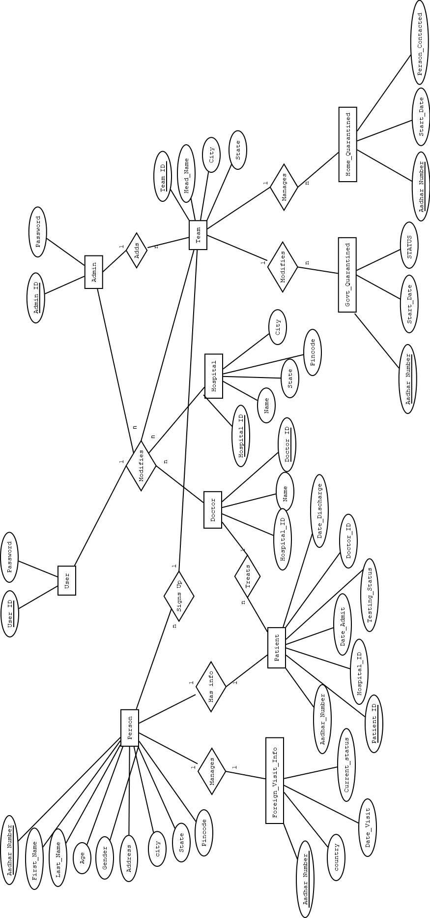

Figure 2.1.1: ER Diagram for COVID-19 application

**2.2 Logical Design**

Person (Aadhar_Number, First_Name, Last_Name, Age, Gender, Address)

Foreign_Visit_Info (Aadhar_Number, Country, Date_Visit, Current_Status)

Hospital (Hospital_ID, Name, Address)

Patient (Aadhar_Number, Patient_ID, Hospital_ID, Date_Admit, Date_Discharge, Testing_Status)

Doctor (Doctor_ID, Name, Hospital_ID)

Team (Team_ID, Head_Name, Address)

Govt_Quarantined (Aadhar_Number, Start_Date, Status)

Home_Quarantined (Aadhar_Number, Start_Date, Person_Contacted)

Team_Hospital (Hospital_ID, Team_ID)

Users (User_ID, Password)

Admin(Admin_ID,Password)

Person

|  |  |  |  |  |  |  |  |  |
| --- | --- | --- | --- | --- | --- | --- | --- | --- |
| Aadhar_Number | First_Name | Last_Name | Age | Gender | City | State | Address_Line | Pincode |

Foreign_Visit_Info

|  |  |  |  |
| --- | --- | --- | --- |
| Aadhar_Number | Country | Date_Visit | Current_Status |

Hospital

|  |  |  |  |  |
| --- | --- | --- | --- | --- |
| Hospital_ID | Name | City | State | Pincode |

Patient

|  |  |  |  |  |  |  |
| --- | --- | --- | --- | --- | --- | --- |
| Aadhar_Number | Paitent_ID | Hospital_ID | Date_Admit | Date_Discharge | Testing_Status | Doctor_ID |

Doctor

|  |  |  |
| --- | --- | --- |
| Doctor_ID | Name | Hospital_ID |

Team

|  |  |  |  |
| --- | --- | --- | --- |
| Team_ID | Head_Name | City | State |

Govt_Quarantined

|  |  |  |
| --- | --- | --- |
| Aadhar_Number | Start_Date | Status |

Home_Quarantined

|  |  |  |
| --- | --- | --- |
| Aadhar_Number | Start_Date | Person_Contacted |

Team_Hospital

|  |  |
| --- | --- |
| Hospital_ID | Team_ID |

Users

|  |  |
| --- | --- |
| User_ID | Password |

Admin

|  |  |
| --- | --- |
| Admin_ID | Password |

Figure 2.2.1: Relational Mapping

**2.3 Normalization**

**The Functional Dependencies**

R(AADHAR_NUMBER,PFIRST_NAME,PLAST_NAME,AGE,GENDER,PADDRESS_LINE,PCITY,PSTATE,PPINCODE,COUNTRY,DATE_VISIT,CURRENT_STATUS,HOSPITAL_ID,HNAME,HCITY,HSTATE,HPINCODE,PATIENT_ID,DATE_ADMIT,DATE_DISCHARGE,TESTING_STATUS,DOCTOR_ID,DNAME, TEAM_ID,HEAD_NAME,TCITY,TSTATE,GSTART_DATE,HSTART_DATE,STATUS,PERSON_CONTACTED, ADMIN_ID,APASSWORD,USER_ID, UPASSWORD)

FD1={AADHAR_NUMBER -> PFIRST_NAME,PLAST_NAME,AGE,GENDER,PADDRESS_LINE,PCITY,PSTATE,PPINCODE,COUNTRY,DATE_VISIT,CURRENT_STATUS,GSTART_DATE,STATUS, HSTART_DATE, PERSON_CONTACTED}

FD2= {HOSPITAL_ID -> HNAME,HCITY,HSTATE,HPINCODE}

FD3={PATIENT_ID-> HOSPITAL_ID ,DATE_ADMIT, DATE_DISCHARGE,TESTING_STATUS,DOCTOR_ID, AADHAR_NUMBER }

FD4={ DOCTOR_ID ->DNAME,HOSPITAL_ID}

FD5={TEAM_ID -> HEAD_NAME,TCITY,TSTATE}

FD6={ADMIN_ID ->APASSWORD}

FD7={USER_ID -> UPASSWORD}

**Dependency graph**

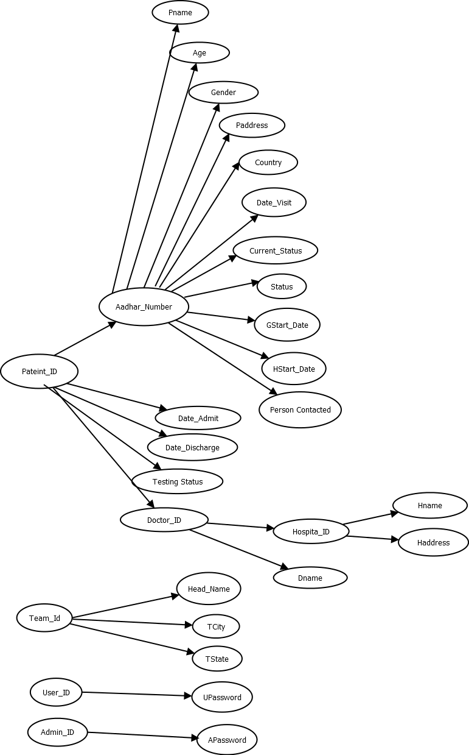

Figure 2.3.1: Dependency Graph

Voi={PFIRST_NAME,PLAST_NAME,AGE,GENDER,PADDRESS_LINE,PCITY,PSTATE,PPINCODE,COUNTRY,DATE_VISIT,CURRENT_STATUS,GSTART_DATE,STATUS, HSTART_DATE, PERSON_CONTACTED, AADHAR_NUMBER, HNAME,HCITY,HSTATE,HPINCODE, HOSPITAL_ID ,DATE_ADMIT, DATE_DISCHARGE,TESTING_STATUS,DOCTOR_ID, AADHAR_NUMBER, DNAME, HEAD_NAME,TCITY,TSTATE, APASSWORD, UPASSWORD }

Vni= {PATIENT_ID, TEAM_ID, ADMIN_ID,USER_ID}

Candidate key= {PATIENT_ID, TEAM_ID, ADMIN_ID, USER_ID}

{PATIENT_ID, TEAM_ID, ADMIN_ID, USER_ID}+={ PFIRST_NAME,PLAST_NAME,AGE,GENDER,PADDRESS_LINE,PCITY,PSTATE,PPINCODE,COUNTRY,DATE_VISIT,CURRENT_STATUS,GSTART_DATE,STATUS, HSTART_DATE, PERSON_CONTACTED, AADHAR_NUMBER, HNAME,HCITY,HSTATE,HPINCODE, HOSPITAL_ID ,DATE_ADMIT,

DATE_DISCHARGE,TESTING_STATUS,DOCTOR_ID, AADHAR_NUMBER, DNAME, HEAD_NAME,TCITY,TSTATE, APASSWORD, UPASSWORD}

**First Normal Form**

The mentioned relation is already in 1NF it does not contain any multi-valued attributes.

**Second Normal Form**

The mentioned relation is not in 2NF.

The candidate keys are {PATIENT_ID, TEAM_ID, ADMIN_ID, USER_ID},

The set of key attributes are: {PATIENT_ID, TEAM_ID, ADMIN_ID, USER_ID}

For each non-trivial FD, check whether the LHS is a proper subset of some candidate key or the RHS are not all key attributes.

checking FD: AADHAR_NUMBER --> PFIRST_NAME,PLAST_NAME,AGE,GENDER,PADDRESS_LINE,PCITY,PSTATE,PPINCODE,COUNTRY,DATE_VISIT,CURRENT_STATUS,GSTART_DATE,HSTART_DATE,STATUS,PERSON_CONTACTED  
checking FD:HOSPITAL_ID-->HNAME,HCITY,HSTATE,HPINCODE  
checking FD: PATIENT_ID --> AADHAR_NUMBER,DATE_ADMIT,DATE_DISCHARGE,TESTING_STATUS,DOCTOR_ID,HOSPITAL_ID  
The FD: violates definition of 2NF -- LHS is a proper subset of some CK.

The FD [PATIENT_ID --> AADHAR_NUMBER] is a partial dependency proper subset the table is split into:  
R1=  
(PATIENT_ID,AADHAR_NUMBER,DATE_ADMIT,DATE_DISCHARGE,TESTING_STATUS,DOCTOR_ID,DNAME,HOSPITAL_ID,PFIRST_NAME,PLAST_NAME,AGE,GENDER,PADDRESS_LINE,PCITY,PSTATE,PPINCODE,COUNTRY,DATE_VISIT,CURRENT_STATUS,GSTART_DATE,HSTART_DATE,STATUS,PERSON_CONTACTED,HNAME,HCITY,HSTATE,HPINCODE), with FDs:

DOCTOR_ID --> HOSPITAL_ID, DNAME

PATIENT_ID-->DOCTOR_ID,AADHAR_NUMBER,DATE_ADMIT, DATE_DISCHARGE, TESTING_STATUS

AADHAR_NUMBER --> PFIRST_NAME,PLAST_NAME,AGE,GENDER,PADDRESS_LINE,PCITY,PSTATE,PPINCODE,COUNTRY,DATE_VISIT,CURRENT_STATUS,GSTART_DATE,HSTART_DATE,STATUS,PERSON_CONTACTED

HOSPITAL_ID --> HNAME, HCITY, HSTATE, HPINCODE

R2=

(PATIENT_ID,TEAM_ID,HEAD_NAME,TCITY,TSTATE,ADMIN_ID,APASSWORD,USER_ID,UPASSWORD), with FDs:

TEAM_ID-->HEAD_NAME,TCITY,TSTATE  
ADMIN_ID-->APASSWORD  
USER_ID --> UPASSWORD

R1 is now in 2NF.

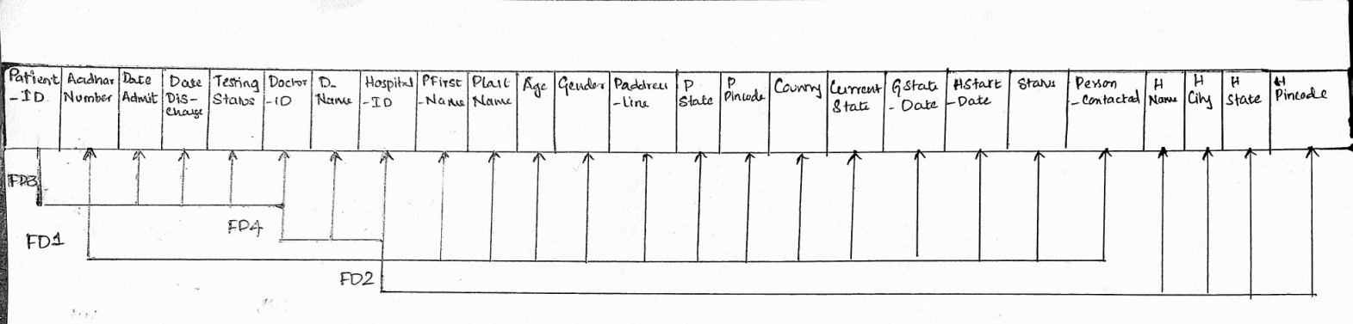

R2 is still not in 2NF hence it is further decomposed.

The FD [TEAM_ID --> HEAD_NAME] is a partial dependency, the table is split into:

R3=(TEAM_ID, HEAD_NAME,TCITY,TSTATE), with FDs:

TEAM_ID --> HEAD_NAME,TCITY,TSTATE

R4=(PATIENT_ID,TEAM_ID,ADMIN_ID,APASSWORD,USER_ID,UPASSWORD), with FDs:

ADMIN_ID-->APASSWORD  
USER_ID --> UPASSWORD

R3 is now in 2NF.

|  |  |  |  |
| --- | --- | --- | --- |
| TEAM_ID | HEAD_NAME | TCITY | TSTATE |

**FD5**

R4 is still not in 2NF hence it is further decomposed.

The FD [ADMIN_ID --> APASSWORD] is a partial dependency ,the table is split into:

R5= (ADMIN_ID,APASSWORD), with FDs:

ADMIN_ID --> APASSWORD

R6=(PATIENT_ID,TEAM_ID,ADMIN_ID,USER_ID,UPASSWORD), with FDs:

USER_ID --> UPASSWORD

R5 is in 2NF.

|  |  |
| --- | --- |
| ADMIN_ID | APASSWORD |

**FD6**

The table R6 is not in 2NF.

The FD [USER_ID --> UPASSWORD] is a partial dependency, the table is split into:

R7=(USER_ID,UPASSWORD),FDs:  
USER_ID-->UPASSWORD

R8= (PATIENT_ID,TEAM_ID,ADMIN_ID,USER_ID), with FDs: NONE

R7 is now in 2NF.

|  |  |
| --- | --- |
| USER_ID | UPASSWORD |

**FD7**

All the tables are in 2NF.

**Third Normal Form**

The above relations are not in third normal form decomposing we will get.

R1 is decomposed to 3NF.

|  |  |  |  |  |  |  |  |  |  |  |  |  |  |  |
| --- | --- | --- | --- | --- | --- | --- | --- | --- | --- | --- | --- | --- | --- | --- |
| Aadhar  _number | Pfirst  _name | Plast  _name | Age | gender | Paddress  line | Pcity | Pstate | Country | Date_  Visit | Current  _status | GStart  _Date | HStart  _date | Status | Person  _Contacted |

**FD1**

HOSPITAL

|  |  |  |  |  |
| --- | --- | --- | --- | --- |
| HOSPITAL_ID | HNAME | HCITY | HSTATE | HPINCODE |

**FD2**

DOCTOR

|  |  |  |
| --- | --- | --- |
| DOCTOR_ID | HOSPITAL_ID | DNAME |

**FD4**

PAITENT

|  |  |  |  |  |  |
| --- | --- | --- | --- | --- | --- |
| PATIENT _ID | AADHAR  _NUMBER | DOCTOR_  ID | DATE_ADMIT | DATE_  DISCHARGE | TESTSING  STATUS |

**FD3**

TEAM

|  |  |  |  |
| --- | --- | --- | --- |
| TEAM_ID | HEAD_NAME | TCITY | TSTATE |

**FD5**

USER

|  |  |
| --- | --- |
| USER_ID | UPASSWORD |

**FD6**

ADMIN

|  |  |
| --- | --- |
| ADMIN_ID | APASSWORD |

**FD7**

**JUSTIFICATION**

• The relations are in 1NF as all attributes are atomic in nature.

• The relations are in 2NF as all the non-prime attributes are fully functional

dependent on the prime attributes.

• The relations are in 3NF as there exist no transitive dependency .

**CHAPTER-3**

**FRONT END DESIGN**

**FRONT END DESIGN**

**3.1 Screen Layout Design**

Using visually attractive and simple design forms the basic of all the screen layout design and using these layout in authentication and login makes it easy to use and user friendly.

Screen layouts determine the overall structure of your screen. They define the structure of a harness included in a composite portal. A harness can contain only one screen layout.

* A screen layout is comprised of the following:
* Header Section
* Navigation Bar(is not there for some pages that require full screen)
* Content Section
* Footer Section

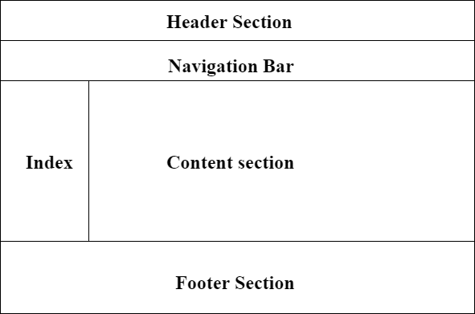

Figure 3.1.1:General Screen Layout

**3.1 Front End Technology**

The technologies that we have used for our front end design are **HTML, CSS, JAVASCRIPT, Java Server Pages (JSP).**

**HTML:** Hypertext Markup Language is the standard markup language for documents designed to be displayed in a web browser. It can be assisted by technologies such as Cascading Style Sheets and scripting languages such as JavaScript.

**CSS:** Cascading Style Sheets is a style sheet language used for describing the presentation of a document written in a markup language such as HTML. CSS is a cornerstone technology of the World Wide Web, alongside HTML and JavaScript.

**JAVASCRIPT:** JavaScript is a text-based programming language used both on the client-side and server-side that allows you to make web pages interactive. Where HTML and CSS are languages that give structure and style to web pages, JavaScript gives web pages interactive elements that engage a user.

**Java Server Pages (JSP):** Java Server Pages (JSP) is a server-side programming technology that enables the creation of dynamic, platform-independent method for building Web-based applications. JSP have access to the entire family of Java APIs, including the JDBC API to access enterprise databases.

**3.2 Connectivity**

package SQL_Support;

import java.util.*;

import java.sql.Connection;

import java.sql.DriverManager;

import org.json.JSONObject;

import DataBase_Interface.Execute_Statement;

import Tables.Contact_Details;

import Tables.Parent_Table;

public class DB_Connect {

// testing purpose

public static void main(String[] args) {

Execute_Statement e = new Execute_Statement();

JSONObject what = new JSONObject();

JSONObject where = new JSONObject();

what.put("Doctor_ID", "abc01");

what.put("Patient_ID", "P0002");

where.put("Testing_Status", "positive");

e.Update(where, what, "Entity_Patient");

}

public static Connection get_Connection(String Username , String Password , String Database_Name) {

Connection connection = null;

try {

Class.forName("com.mysql.jdbc.Driver").getConstructor().newInstance();

Connection=DriverManager.getConnection("jdbc:mysql://localhost:3306/"+Database_Name,Username,Password);

}

catch (Exception e)

{

System.out.print("Unable to connect to DataBase "+Database_Name+" , with Username "+Username + " and Password "+ Password);

System.out.println(e);

}

return connection;

}

}

**CHAPTER-4**

**MAJOR MODULES**

**MAJOR MODULES**

**4.1 Citizen Module**

4.1.1 View Hospitals in Locality

The user can view the hospital in the specified locality.

4.1.2 View the cases in Locality

The user can view the number of cases in the specified locality.

4.1.3 View total number of cases in India

The user can view the total number of cases in India.

4.1.4 Foreign Visit Form

If the user has visited any foreign country then fill details in form.

4.1.5 Update Details

This portal allows the user to update their aadhar number and age.

**4.2 Hospital Module**

4.2.1 View new patient list

The user can view the list of new patients entered in the system.

4.2.1.1 Assign doctor

The user can assign a doctor to the new patient.

4.2.2 View complete list of patients

The user can view the complete list of patients in the system.

4.2.3 View particular patient info

The user can view the information\details of the required patient .

4.2.4 View doctors list

The user can view the list of doctors present in the hospital.

4.2.5 Add doctor

The user can add the doctors .

4.2.6 Add a hospital

The user can add a hospital

4.2.7 View cases

The user can view the cases in the specified hospital.

**4.3 Doctor Module**

4.3.1 Add a patient

The doctor can add a new patient .

4.3.2 View my patient List

The doctor can view the list of his patients.

4.3.3 Update status

The doctor can update the status of his patient

**4.4 Team Module**

4.4.1 Sign up a person.

The user can sign up a person for covid test.

4.4.2 View Hospitals

The user can view the covid dedicated hospitals.

4.4.3 Home Quarantine

The user can view the people who are on home quarantine and add the person

to the govt quarantine.

4.4.4 Govt quarantine

The user can view people in govt quarantine.

**4.5 Admin Module**

4.5.1 Foreign Visit

If the user has visited any foreign country then he\she has to fill their

details in the foreign visit form.

4.5.2 Cases and analysis

4.5.2.1 State-wise analysis

The admin can view the number of cases in state.

4.5.2.2 City-wise analysis

The admin can view the number of cases in each city of a state.

4.5.2.3 Date wise analysis

The admin can view the number of cases each day.

4.5.3 Hospitals and Teams

4.5.3.1 Hospitals in Locality

The admin can view the hospitals treating covid-19 patients in

locality.

4.5.3.2 View teams

The admin can view the list of team members.

4.5.3.3 Add a team

The admin can add a new team member.

**CHAPTER-5**

**IMPLEMENTATION**

**IMPLEMENTATION**

**5.1 CREATE STATEMENTS**

Create Table Person (

Aadhar_Number BIGINT CONSTRAINT TWELVE_DIGITS CHECK (Aadhar_Number >=100000000000 and Aadhar_Number <=999999999999 ) ,

First_Name VARCHAR (20) ,

Last_Name VARCHAR (20) ,

Age INT CONSTRAINT THREE_DIGITS_MAX CHECK (AGE >=0 and Age <=150 ) ,

Gender VARCHAR(9) CONSTRAINT MF CHECK( Gender in ('Male', 'Female' , 'others') ) ,

Address_Line_1 VARCHAR(100) ,

City VARCHAR(30) ,

State VARCHAR(30) ,

PinCode INT CONSTRAINT SIX_DIGITS CHECK (PinCode >=100000 and PinCode <=999999 ) ,

CONSTRAINT PERSON_PK PRIMARY KEY (Aadhar_Number)

) ;

Create Table Foreign_Visit_Info (

Aadhar_Number BIGINT CONSTRAINT fvi_TWELVE_DIGITS CHECK (Aadhar_Number >=100000000000 and Aadhar_Number <=999999999999 ) ,

Country VARCHAR (20) ,

Date_Visit Date,

Current_Status VARCHAR (30) ,

CONSTRAINT Foreign_Visit_Info_PK PRIMARY KEY (Aadhar_Number)

) ;

Create Table Hospital (

Hospital_ID VARCHAR(5) ,

Name VARCHAR(20) ,

City VARCHAR(20) ,

State VARCHAR(20) ,

Pincode VARCHAR(6),

CONSTRAINT Hospital_PK PRIMARY KEY (Hospital_ID)

) ;

Create Table Patient (

Aadhar_Number BIGINT CONSTRAINT patient_TWELVE_DIGITS CHECK (Aadhar_Number >=100000000000 and Aadhar_Number <=999999999999 ) ,

Patient_ID VARCHAR(5),

Hospital_ID VARCHAR(5),

Date_Admit Date ,

Date_Discharge Date ,

Testing_Status VARCHAR(50),

Doctor_ID VARCHAR(5) ,

CONSTRAINT Patient_PK PRIMARY KEY (Patient_ID)

) ;

Create Table Doctor (

Doctor_ID VARCHAR(5) ,

Name VARCHAR(20) ,

Hospital_ID VARCHAR(5),

CONSTRAINT Doctor_PK PRIMARY KEY (Doctor_ID)

) ;

Create Table Team (

Team_ID VARCHAR(5) ,

Head_Name VARCHAR(20) ,

City VARCHAR(20),

State VARCHAR(20),

CONSTRAINT Team_PK PRIMARY KEY (Team_ID) ) ;

Create Table Govt_Quarantined(

Aadhar_Number BIGINT CONSTRAINT patient_TWELVE_DIGITS CHECK (Aadhar_Number >=100000000000 and Aadhar_Number <=999999999999 ) ,

Start_Date DATE,

STATUS Varchar(10 ) CONSTRAINT status_constraint check (STATUS in ('none' , 'positive' ,'negative')),

CONSTRAINT Govt_Quarantined_pk PRIMARY KEY (Aadhar_Number)

) ;

Create Table Home_Quarantined(

Aadhar_Number BIGINT CONSTRAINT Home_Quarnatine_12 CHECK (Aadhar_Number >=100000000000 and Aadhar_Number <=999999999999 ) ,

Start_Date DATE,

Person_Contacted BIGINT CONSTRAINT Home_Quarantined_12 CHECK (Person_Contacted >=100000000000 and Person_Contacted <=999999999999 ) ,

CONSTRAINT Home_Quarantined_pk PRIMARY KEY (Aadhar_Number)

) ;

Create Table Govt_Quarantine_Buffer (

Aadhar_Number BIGINT CONSTRAINT buffer12 CHECK (Aadhar_Number >=100000000000 and Aadhar_Number <=999999999999 ) ,

CONSTRAINT Govt_Quarantine_Buffer_pk PRIMARY KEY (Aadhar_Number)

) ;

Create Table Patient_Buffer (

Aadhar_Number BIGINT CONSTRAINT Pbuffer12 CHECK (Aadhar_Number >=100000000000 and Aadhar_Number <=999999999999 ) ,

Hospital_ID VARCHAR(5),

CONSTRAINT Govt_Quarantine_buffer_pk PRIMARY KEY (Aadhar_Number)

) ;

Create Table Team_Hospital (

Hospital_ID VARCHAR(5),

Team_ID VARCHAR(5),

CONSTRAINT team_hospital_pk PRIMARY KEY (hospital_id , team_id)

) ;

create table Users (

User_ID VARCHAR(10),

Password VARCHAR(10),

CONSTRAINT Users_pk PRIMARY KEY (User_id)

);

create table Admin (

Admin_ID VARCHAR(10),

Password VARCHAR(10),

CONSTRAINT Users_pk PRIMARY KEY (User_id)

);

**5.2 JAVA CONTROLLERS**

|  |
| --- |
| package DataBase_Interface; |
|  |  |
|  | import java.sql.SQLException; |
|  | import java.util.ArrayList; |
|  |  |
|  | import org.json.JSONObject; |
|  |  |
|  | import SQL_Support.SQL_Commands; |
|  |  |
|  | public class Execute_Statement { |
|  | private SQL_Commands sql; |
|  | private String pika_test = "Pika Pika"; |
|  | public Execute_Statement() { |
|  | // TODO Auto-generated constructor stub |
|  | sql = new SQL_Commands("root", new Database_Auth().password, "cms"); |
|  | } |
|  |  |
|  | public void Insert(JSONObject obj, String view) { |
|  | try { |
|  | Entity entity = new Entity(); |
|  | System.out.println(entity); |
|  | JSONObject[] obj_array = entity.Split_Json_Objects(obj, view); |
|  | if (!Possible(obj_array)) { |
|  | throw new Exception ("Insert could not be performed"); |
|  | } |
|  | for (JSONObject object : obj_array) { |
|  | object.remove("Status"); |
|  | sql.Insert(object); |
|  | } |
|  | } catch (Exception e) { |
|  | System.out.println(e); |
|  | System.out.println("error in insert Execute_Statement"); |
|  | } |
|  | } |
|  | public void Delete(JSONObject obj, String view) { |
|  | try { |
|  | Entity entity = new Entity(); |
|  | JSONObject[] obj_array = entity.Split_Json_Objects(obj, view); |
|  |  |
|  | if (!Possible(obj_array)) { |
|  | throw new Exception ("Insert could not be performed"); |
|  | } |
|  |  |

|  |  |
| --- | --- |
|  | for (JSONObject object : obj_array) { |
|  | object.remove("Status"); |
|  | sql.Delete(object); |
|  | } |
|  | } catch (Exception e) { |
|  | System.out.println(e); |
|  | System.out.println("error in delete Execute_Statement"); |
|  | } |
|  | } |
|  | public void Update(JSONObject what , JSONObject where , String view) { |
|  | try { |
|  |  |
|  | Entity entity = new Entity(); |
|  | JSONObject[] what_array = entity.Split_Json_Objects(what, view); |
|  | JSONObject[] where_array = entity.Split_Json_Objects(where, view); |
|  |  |
|  | if (!Possible(where_array)) { |
|  | throw new Exception ("Update could not be performed"); |
|  |  |
|  | } |
|  | for (int i = 0 ; i<where_array.length; i++) { |
|  | where_array[i].remove("Status"); |
|  | what_array[i].remove("Status"); |
|  | sql.Update(what_array[i] , where_array[i]); |
|  | } |
|  |  |
|  | } catch (Exception e) { |
|  | System.out.println(e); |
|  | System.out.println("error in update Execute_Statement"); |
|  | } |
|  | } |
|  | public ArrayList<JSONObject> Read(JSONObject obj, String type) { |
|  | try { |
|  | System.out.println("Values Received : "); |
|  | System.out.println(obj); |
|  | System.out.println(type); |
|  | Get_Read_Query read = new Get_Read_Query(); |
|  | String required_Query = read.get(obj, type); |
|  | System.out.print("Query Reqd : " + required_Query); |
|  | return (ArrayList<JSONObject>) sql.Read(required_Query, read.values , read.features); |
|  |  |
|  | } catch (Exception e) { |
|  | System.out.println(e); |
|  | System.out.println("Error in Read Execute_Statement"); |

|  |  |
| --- | --- |
|  | } |
|  | return null; |
|  |  |
|  |  |
|  | } |
|  |  |
|  | public boolean Possible(JSONObject[] obj) { |
|  | for (JSONObject object : obj) { |
|  | if (object.get("Status").equals("NOT OK")) { |
|  | return false; |
|  | } |
|  | } |
|  | return true; |
|  | } |
|  | } |

**5.3 VIEW**

**DOCTOR INFO:**

<%@page import=*"java.util.*"*%>

<%@page import=*"DataBase_Interface.Execute_Statement"*%>

<%@page import=*"org.json.JSONObject"*%>

<%@ page language=*"java"* contentType=*"text/html; charset=ISO-8859-1"*

pageEncoding=*"ISO-8859-1"*%>

<!DOCTYPE html>

<html>

<head>

<meta charset=*"ISO-8859-1"*>

<title>Insert title here</title>

<link rel=*"stylesheet"* href=*"https://stackpath.bootstrapcdn.com/bootstrap/4.5.0/css/bootstrap.min.css"* integrity=*"sha384-9aIt2nRpC12Uk9gS9baDl411NQApFmC26EwAOH8WgZl5MYYxFfc+NcPb1dKGj7Sk"* crossorigin=*"anonymous"*>

<script src=*"https://code.jquery.com/jquery-3.5.1.slim.min.js"* integrity=*"sha384-DfXdz2htPH0lsSSs5nCTpuj/zy4C+OGpamoFVy38MVBnE+IbbVYUew+OrCXaRkfj"* crossorigin=*"anonymous"*></script>

<script src=*"https://cdn.jsdelivr.net/npm/popper.js@1.16.0/dist/umd/popper.min.js"* integrity=*"sha384-Q6E9RHvbIyZFJoft+2mJbHaEWldlvI9IOYy5n3zV9zzTtmI3UksdQRVvoxMfooAo"* crossorigin=*"anonymous"*></script>

<link rel=*"stylesheet"* type=*"text/css"* href=*"style.css"*>

</head>

<body>

<%

String userName = **null**;

Cookie[] cookies = request.getCookies();

**if**(cookies !=**null**){

**for**(Cookie cookie : cookies){

**if**(cookie.getName().equals("user"))

userName = cookie.getValue();

//out.println("Value : " + cookie.getValue());

}

}

**if**(userName == **null**)

userName = "ADMIN_NULL";

String hid = userName;

JSONObject obj1 = **new** JSONObject();

obj1.put("Hospital_ID",hid);

Execute_Statement e = **new** Execute_Statement();

ArrayList<JSONObject> list = e.Read(obj1,"Doctor_Info");

%>

<table id=*"Table"* class=*"table table-hover border border-dark"*>

<thead>

<%

**for**(JSONObject obj : list){

Iterator<String> keysItr = obj.keys();

**while**(keysItr.hasNext()){

String key = keysItr.next();

%>

<th><%=key %></th>

<%

}

**break**;

}

%>

</thead><tbody>

<%

**for**(JSONObject obj : list){

Iterator<String> keysItr = obj.keys();

%>

<tr>

<%

**while**(keysItr.hasNext()){

String key = keysItr.next();

Object value = obj.get(key);

%>

<td><%=value %></td>

<%

}

%>

</tr>

<%

}

%>

</tbody></table>

<a href=*"../people/hospital.jsp"*><h3>Go Back</h3></a>

</body>

</html>

**FOREIGN VISIT:**

<%@page import=*"DataBase_Interface.Execute_Statement"*%>

<%@page import=*"java.util.ArrayList"*%>

<%@page import=*"org.json.JSONObject"*%>

<%@ page language=*"java"* contentType=*"text/html; charset=ISO-8859-1"*

pageEncoding=*"ISO-8859-1"*%>

<!DOCTYPE html>

<html>

<head>

<meta charset=*"ISO-8859-1"*>

<title>Insert title here</title>

</head>

<body>

<%

String city = request.getParameter("city");

JSONObject obj = **new** JSONObject();

obj.put("city",city);

Execute_Statement e = **new** Execute_Statement();

ArrayList<JSONObject> c = e.Read(obj, "Foreign_List");

out.println(c);

%>

</body>

</html>

**HOSPITAL CASES:**

<%@page import=*"java.util.*"*%>

<%@page import=*"DataBase_Interface.Execute_Statement"*%>

<%@page import=*"org.json.JSONObject"*%>

<%@ page language=*"java"* contentType=*"text/html; charset=ISO-8859-1"*

pageEncoding=*"ISO-8859-1"*%>

<!DOCTYPE html>

<html>

<head>

<meta charset=*"ISO-8859-1"*>

<title>Insert title here</title>

<link rel=*"stylesheet"* href=*"https://stackpath.bootstrapcdn.com/bootstrap/4.5.0/css/bootstrap.min.css"*

integrity=*"sha384-9aIt2nRpC12Uk9gS9baDl411NQApFmC26EwAOH8WgZl5MYYxFfc+NcPb1dKGj7Sk"*

<script src=*"https://code.jquery.com/jquery-3.5.1.slim.min.js"* integrity=*"sha384-DfXdz2htPH0lsSSs5nCTpuj/zy4C+OGpamoFVy38MVBnE+IbbVYUew+OrCXaRkfj"* crossorigin=*"anonymous"*></script>

<script src=*"https://cdn.jsdelivr.net/npm/popper.js@1.16.0/dist/umd/popper.min.js"* integrity=*"sha384-Q6E9RHvbIyZFJoft+2mJbHaEWldlvI9IOYy5n3zV9zzTtmI3UksdQRVvoxMfooAo"* crossorigin=*"anonymous"*></script>

<link rel=*"stylesheet"* type=*"text/css"* href=*"style.css"*>

</head>

<body>

<%

String userName = **null**;

Cookie[] cookies = request.getCookies();

**if**(cookies !=**null**){

**for**(Cookie cookie : cookies){

**if**(cookie.getName().equals("user"))

userName = cookie.getValue();

//out.println("Value : " + cookie.getValue());

}

}

**if**(userName == **null**)

userName = "ADMIN_NULL";

String hid = userName;

String type = request.getParameter("type");

JSONObject obj1 = **new** JSONObject();

obj1.put("Hospital_ID",hid);

Execute_Statement e = **new** Execute_Statement();

ArrayList<JSONObject> list = e.Read(obj1,type);

%>

<table id=*"Table"* class=*"table table-hover border border-dark"*>

<thead>

<%

**for**(JSONObject obj : list){

Iterator<String> keysItr = obj.keys();

**while**(keysItr.hasNext()){

String key = keysItr.next();

%>

<th><%=key %></th>

<%

}

**break**;

}

%>

</thead><tbody>

<%

**for**(JSONObject obj : list){

Iterator<String> keysItr = obj.keys();

%>

<tr>

<%

**while**(keysItr.hasNext()){

String key = keysItr.next();

Object value = obj.get(key);

%>

<td><%=value %></td>

<%

}

%>

</tr>

<%

}

%>

</tbody>

</table>

<a href=*"../people/hospital.jsp"*><h3>Go Back</h3></a>

</body>

</html>

**PATIENTS LIST:**

<%@page import=*"java.util.*"*%>

<%@page import=*"DataBase_Interface.Execute_Statement"*%>

<%@page import=*"org.json.JSONObject"*%>

<%@ page language=*"java"* contentType=*"text/html; charset=ISO-8859-1"*

pageEncoding=*"ISO-8859-1"*%>

<!DOCTYPE html>

<html>

<head>

<meta charset=*"ISO-8859-1"*>

<title>Insert title here</title>

<link rel=*"stylesheet"* href=*"https://stackpath.bootstrapcdn.com/bootstrap/4.5.0/css/bootstrap.min.css"* integrity=*"sha384-9aIt2nRpC12Uk9gS9baDl411NQApFmC26EwAOH8WgZl5MYYxFfc+NcPb1dKGj7Sk"* crossorigin=*"anonymous"*>

<script src=*"https://code.jquery.com/jquery-3.5.1.slim.min.js"* integrity=*"sha384-DfXdz2htPH0lsSSs5nCTpuj/zy4C+OGpamoFVy38MVBnE+IbbVYUew+OrCXaRkfj"* crossorigin=*"anonymous"*></script>

<script src=*"https://cdn.jsdelivr.net/npm/popper.js@1.16.0/dist/umd/popper.min.js"* integrity=*"sha384-Q6E9RHvbIyZFJoft+2mJbHaEWldlvI9IOYy5n3zV9zzTtmI3UksdQRVvoxMfooAo"* crossorigin=*"anonymous"*></script>

<link rel=*"stylesheet"* type=*"text/css"* href=*"style.css"*>

</head>

<body>

<%

String userName = **null**;

Cookie[] cookies = request.getCookies();

**if**(cookies !=**null**){

**for**(Cookie cookie : cookies){

**if**(cookie.getName().equals("user"))

userName = cookie.getValue();

//out.println("Value : " + cookie.getValue());

}

}

**if**(userName == **null**)

userName = "ADMIN_NULL";

String hid = userName;

JSONObject obj1 = **new** JSONObject();

obj1.put("Hospital_ID",hid);

Execute_Statement e = **new** Execute_Statement();

ArrayList<JSONObject> list = e.Read(obj1, "Patient_List");

%>

<table id=*"Table"* class=*"table table-hover border border-dark"*>

<thead>

<%

ArrayList<String> keys = **new** ArrayList<String>(20);

**for**(JSONObject obj : list){

Iterator<String> keysItr = obj.keys();

**while**(keysItr.hasNext()){

String key = keysItr.next();

keys.add(key);

%>

<th><%=key %></th>

<%

}

**break**;

}

%>

</thead><tbody>

<%

**for**(JSONObject obj : list){

%>

<tr>

<%

**for**(String k : keys){

**if**(obj.has(k)){

%> <td><%=obj.get(k) %></td>

<% }

**else**{

%> <td>----</td>

<% }

}

%>

<%

}

%>

</tr>

</tbody>

</table>

<a href=*"../people/hospital.jsp"*><h3>Go Back</h3></a>

</body>

</html>

**TEAMS:**

<%@page import=*"java.util.*"*%>

<%@page import=*"DataBase_Interface.Execute_Statement"*%>

<%@page import=*"org.json.JSONObject"*%>

<%@ page language=*"java"* contentType=*"text/html; charset=ISO-8859-1"*

pageEncoding=*"ISO-8859-1"*%>

<!DOCTYPE html>

<html>

<head>

<meta charset=*"ISO-8859-1"*>

<title>Team Read</title>

<link rel=*"stylesheet"* href=*"https://stackpath.bootstrapcdn.com/bootstrap/4.5.0/css/bootstrap.min.css"* integrity=*"sha384-9aIt2nRpC12Uk9gS9baDl411NQApFmC26EwAOH8WgZl5MYYxFfc+NcPb1dKGj7Sk"* crossorigin=*"anonymous"*>

<script src=*"https://code.jquery.com/jquery-3.5.1.slim.min.js"* integrity=*"sha384-DfXdz2htPH0lsSSs5nCTpuj/zy4C+OGpamoFVy38MVBnE+IbbVYUew+OrCXaRkfj"* crossorigin=*"anonymous"*></script>

<script src=*"https://cdn.jsdelivr.net/npm/popper.js@1.16.0/dist/umd/popper.min.js"* integrity=*"sha384-Q6E9RHvbIyZFJoft+2mJbHaEWldlvI9IOYy5n3zV9zzTtmI3UksdQRVvoxMfooAo"* crossorigin=*"anonymous"*></script>

<link rel=*"stylesheet"* type=*"text/css"* href=*"style.css"*>

</head>

<body>

<%

JSONObject obj1 = **new** JSONObject();

Execute_Statement e = **new** Execute_Statement();

ArrayList<JSONObject> list = e.Read(obj1,"Teams");

%>

<table id=*"Table"* class=*"table table-hover border border-dark"*>

<thead>

<%

**for**(JSONObject obj : list){

Iterator<String> keysItr = obj.keys();

**while**(keysItr.hasNext()){

String key = keysItr.next();

%>

<th><%=key %></th>

<%

}

**break**;

}

%>

</thead><tbody>

<%

**for**(JSONObject obj : list){

Iterator<String> keysItr = obj.keys();

%>

<tr>

<%

**while**(keysItr.hasNext()){

String key = keysItr.next();

Object value = obj.get(key);

%>

<td><%=value %></td>

<%

}

%>

</tr>

<%

}

%>

</tbody></table>

<a href=*"../people/admin.jsp"*><h3>Go Back</h3></a>

</body>

</html>

**TOTAL CASES:**

<%@page import=*"java.util.*"*%>

<%@page import=*"DataBase_Interface.Execute_Statement"*%>

<%@page import=*"org.json.JSONObject"*%>

<%@ page language=*"java"* contentType=*"text/html; charset=ISO-8859-1"*

pageEncoding=*"ISO-8859-1"*%>

<!DOCTYPE html>

<html>

<head>

<meta charset=*"ISO-8859-1"*>

<title>Insert title here</title>

<link rel=*"stylesheet"* href=*"https://stackpath.bootstrapcdn.com/bootstrap/4.5.0/css/bootstrap.min.css"* integrity=*"sha384-9aIt2nRpC12Uk9gS9baDl411NQApFmC26EwAOH8WgZl5MYYxFfc+NcPb1dKGj7Sk"* crossorigin=*"anonymous"*>

<script src=*"https://code.jquery.com/jquery-3.5.1.slim.min.js"* integrity=*"sha384-DfXdz2htPH0lsSSs5nCTpuj/zy4C+OGpamoFVy38MVBnE+IbbVYUew+OrCXaRkfj"* crossorigin=*"anonymous"*></script>

<script src=*"https://cdn.jsdelivr.net/npm/popper.js@1.16.0/dist/umd/popper.min.js"* integrity=*"sha384-Q6E9RHvbIyZFJoft+2mJbHaEWldlvI9IOYy5n3zV9zzTtmI3UksdQRVvoxMfooAo"* crossorigin=*"anonymous"*></script>

<link rel=*"stylesheet"* type=*"text/css"* href=*"style.css"*>

</head>

<body>

<%

JSONObject obj1 = **new** JSONObject();

Execute_Statement read_obj = **new** Execute_Statement();

ArrayList<JSONObject> list = read_obj.Read(obj1, "Total_Cases");

%>

<table id=*"Table"* class=*"table table-hover border border-dark"*>

<thead>

<%

**for**(JSONObject obj : list){

Iterator<String> keysItr = obj.keys();

**while**(keysItr.hasNext()){

String key = keysItr.next();

%>

<th><%=key %></th>

<%

}

}

%>

</thead>

<tbody>

<tr>

<%

**for**(JSONObject obj : list){

Iterator<String> keysItr = obj.keys();

**while**(keysItr.hasNext()){

String key = keysItr.next();

Object value = obj.get(key);

%>

<td><%=value %></td>

<%

}

}

%>

</tr>

</tbody>

</table>

<a href=*"../people/citizen.jsp"*><h3>Go Back</h3></a>

</body>

</html>

**CHAPTER-6**

**SNAPSHOTS**

**SNAPSHOTS**

**6.1 SCREEN SHOTS**

1. HOME PAGE

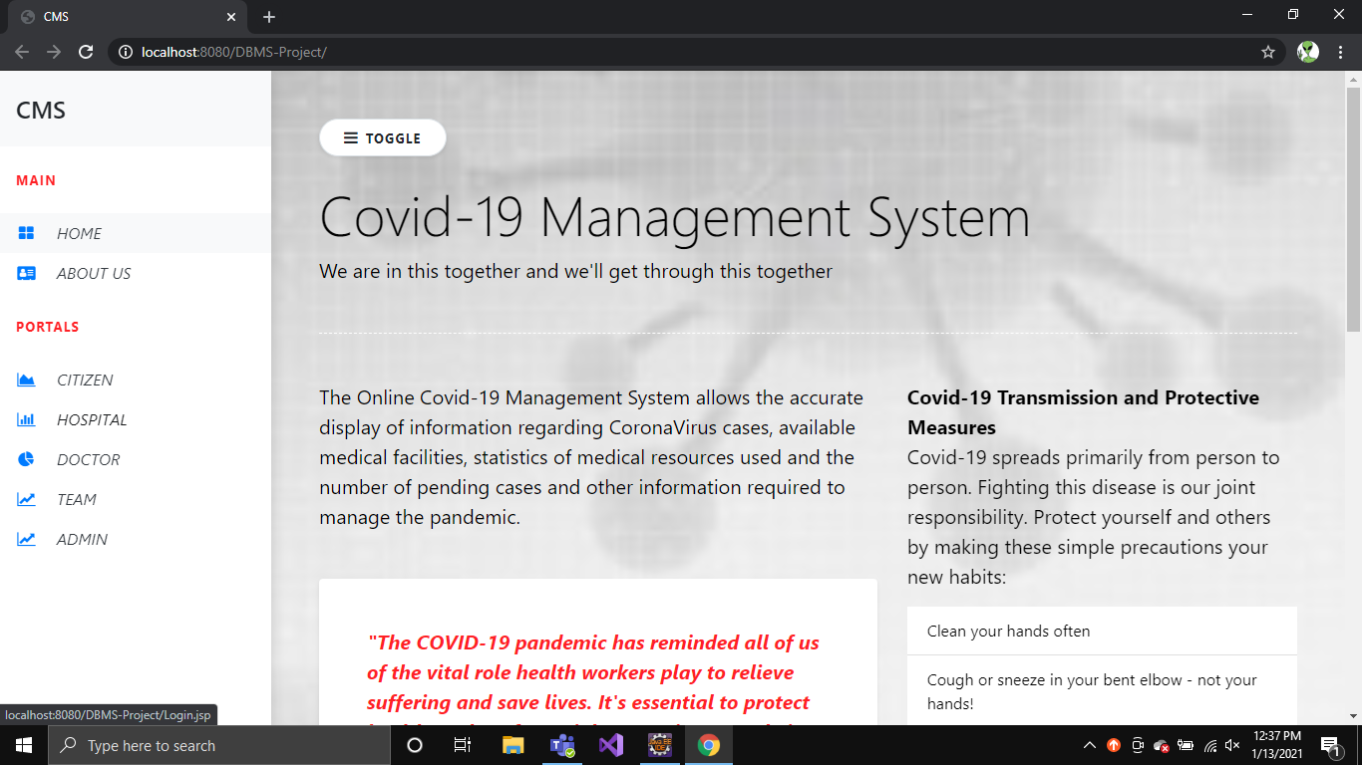

Figure 6.1.1: Home page

2. USER LOGIN

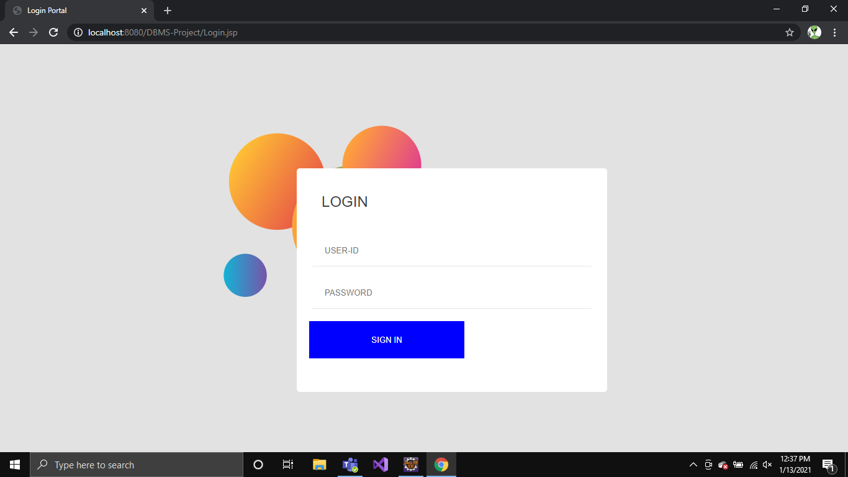

Figure 6.1.2: User login portal

3. VIEW HOSPITALS IN LOCALITY

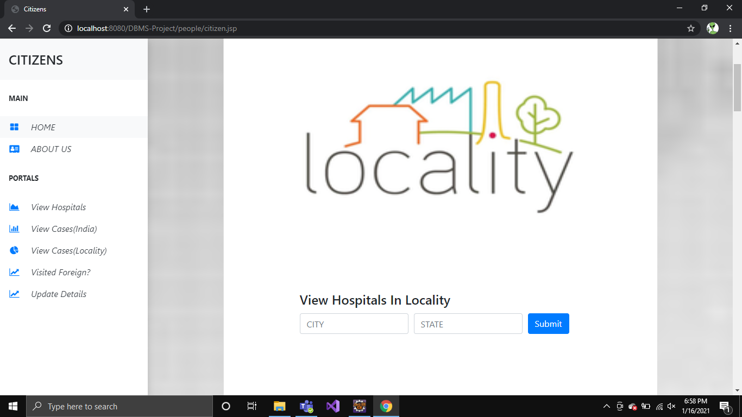

Figure 6.1.3: View hospitals in the locality

4. HOSPITAL LIST

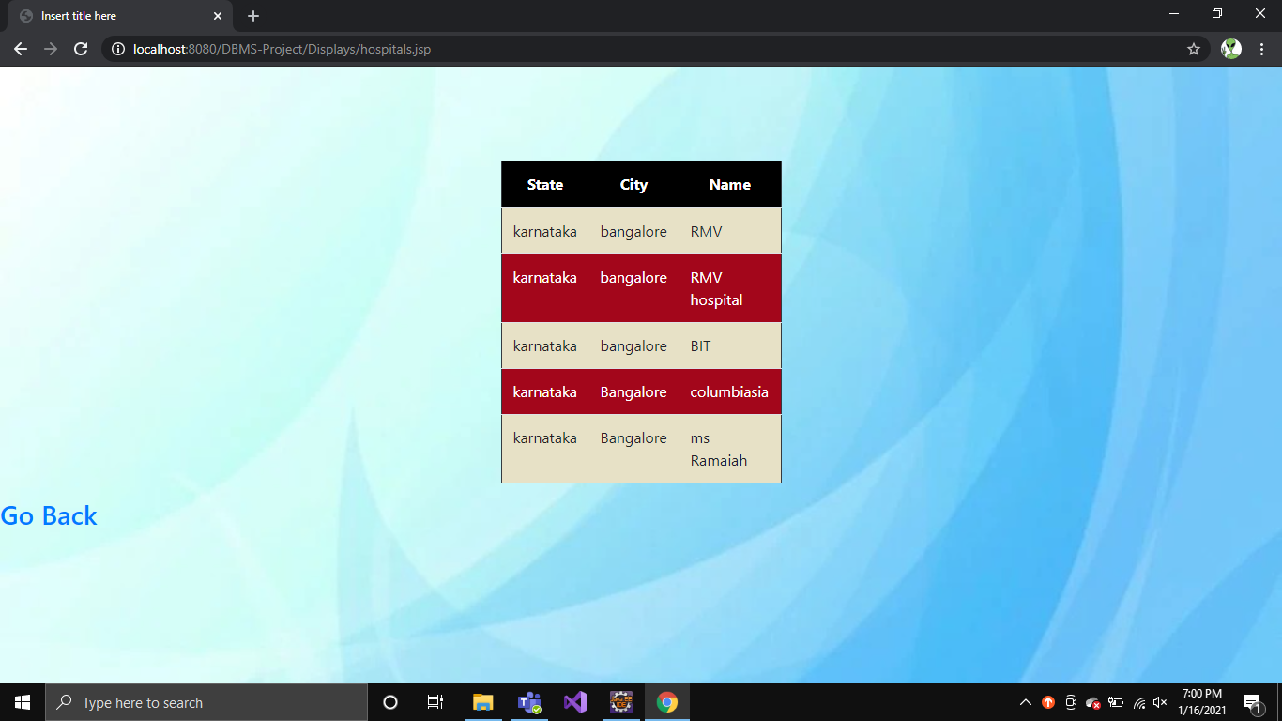

Figure 6.1.4: List of hospitals in the locality

5. VIEW CASES IN LOCLAITY

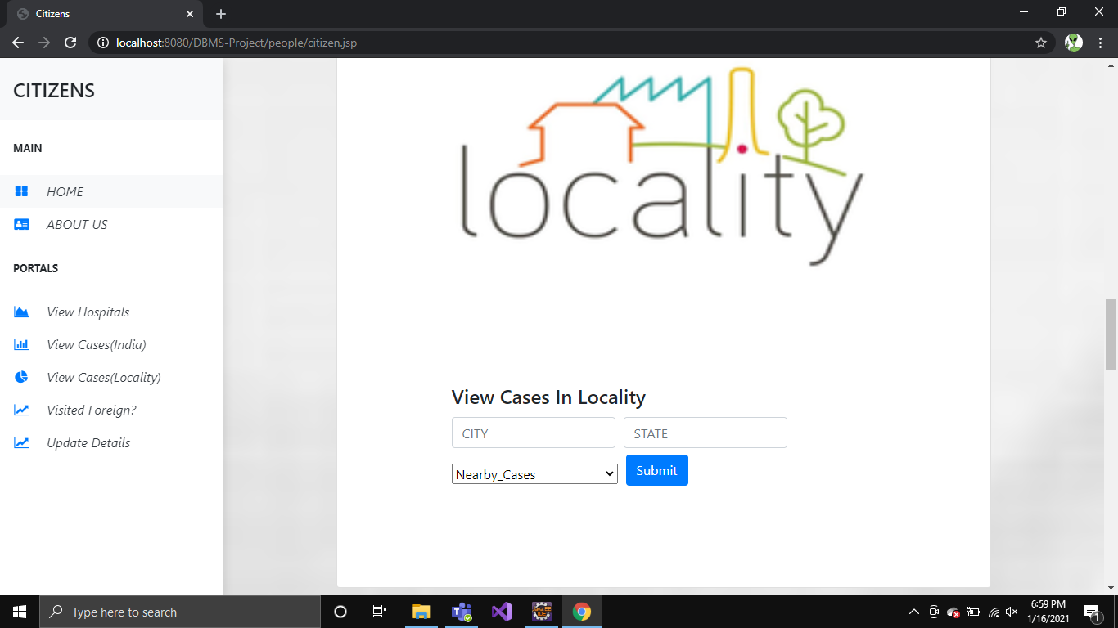

Figure 6.1.5: View cases in Locality

6. CASES LIST

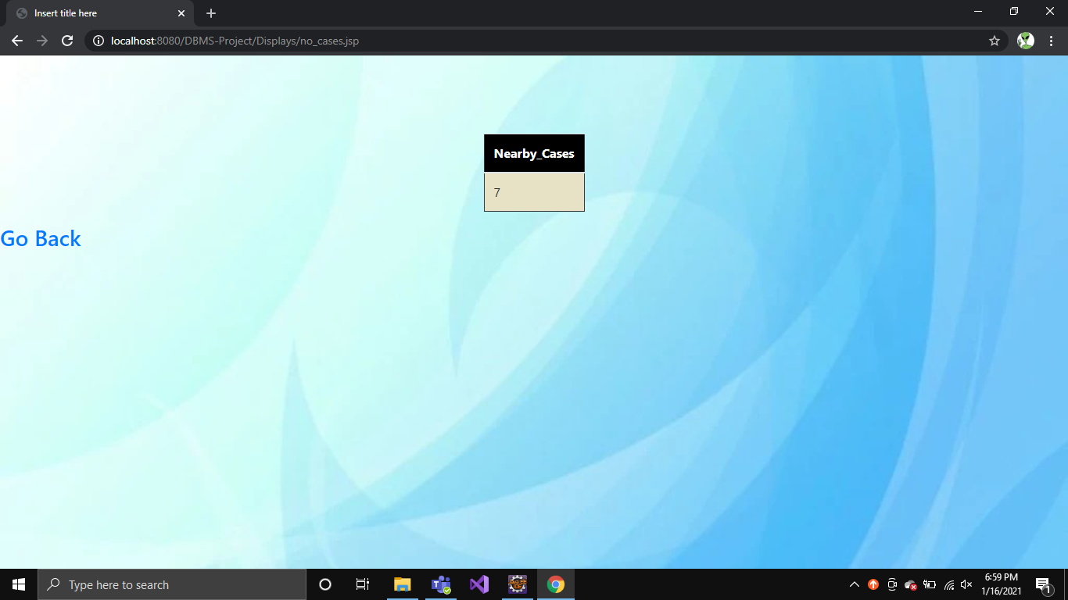

Figure 6.1.6: List of nearby cases in locality

7. TOTAL CASES IN INDIA

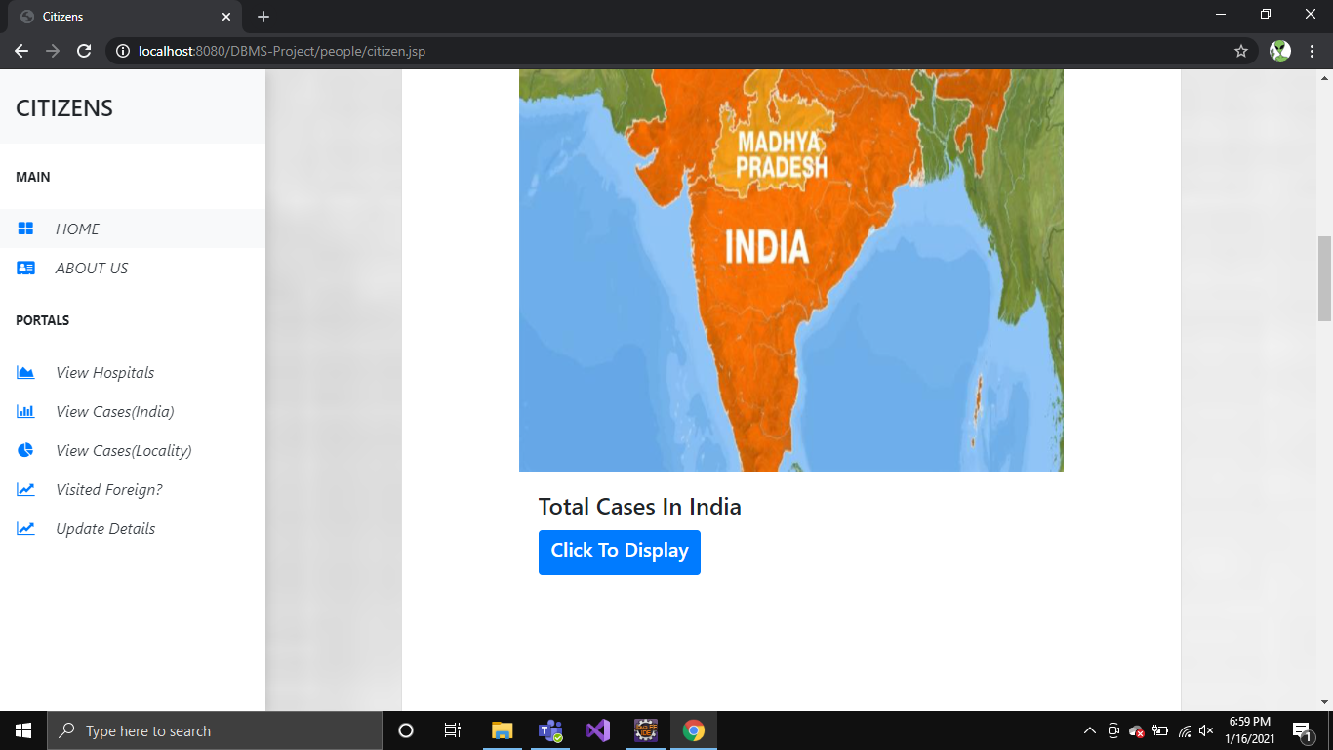

Figure 6.1.7: Total cases in India

8. NUMBER OF CASES IN INDIA

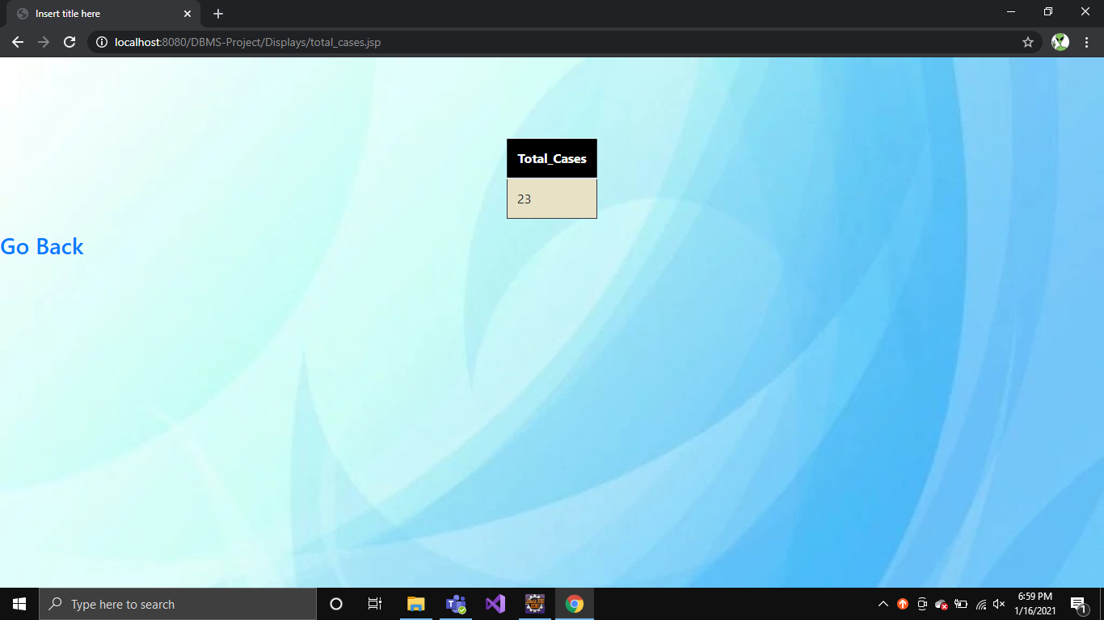

Figure 6.1.8: Number of cases in India

9. VISITED FOREIGN?

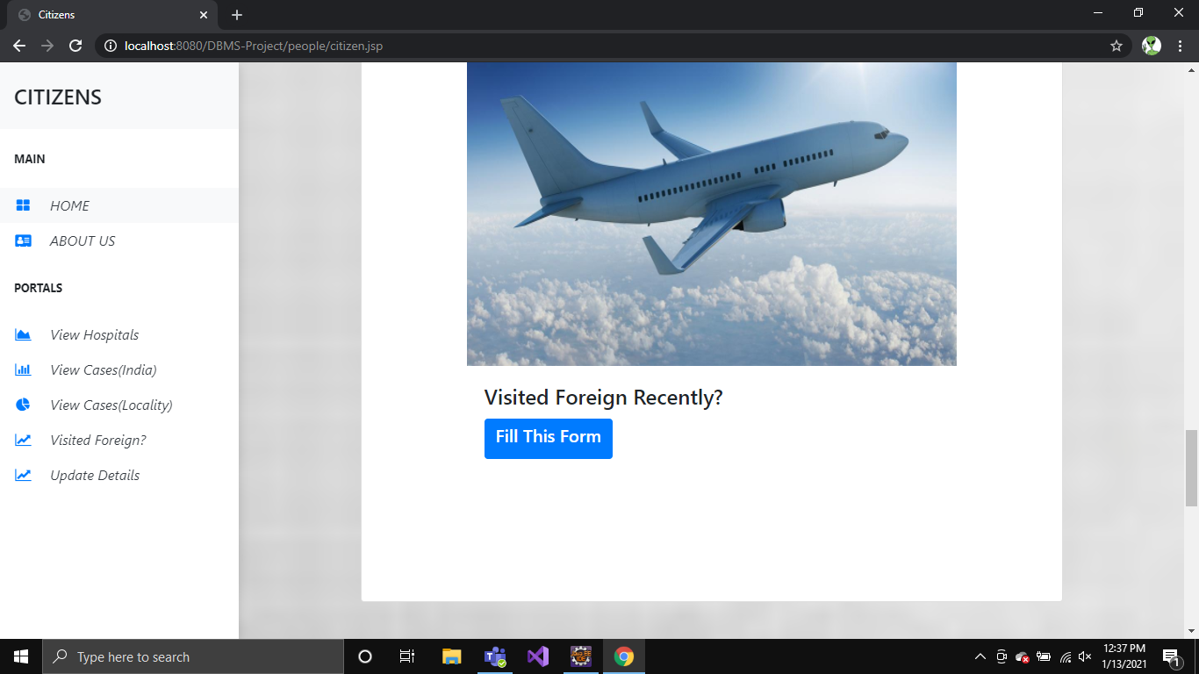

Figure 6.1.9: Portal for foreign visit form

10. FOREIGN VISIT FORM

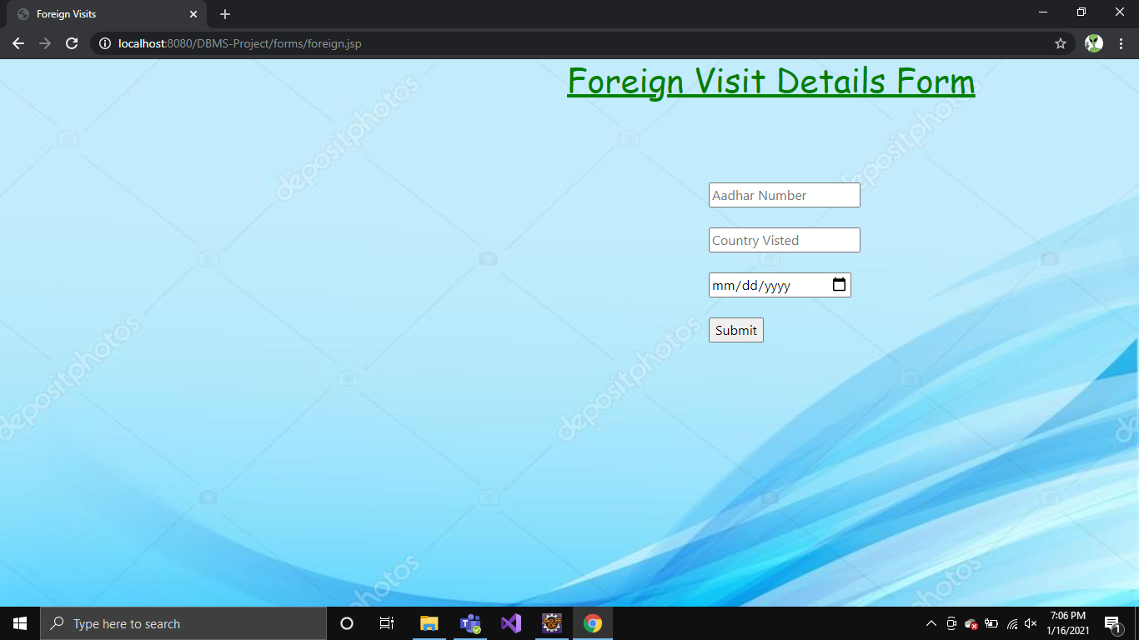

Figure 6.1.10: Foreign visit form details

11. CONFIRMING THE FORM

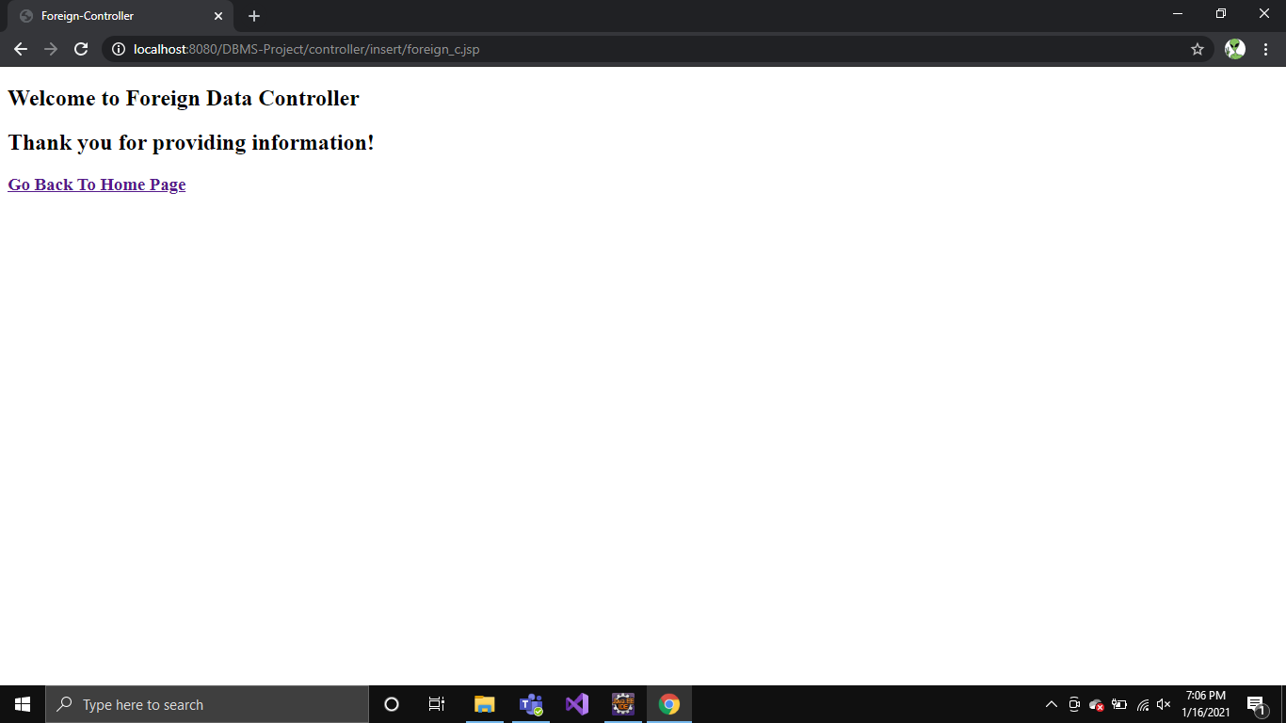

Figure 6.1.11: Welcome to Foreign Data Controller

12. UPDATE DETAILS

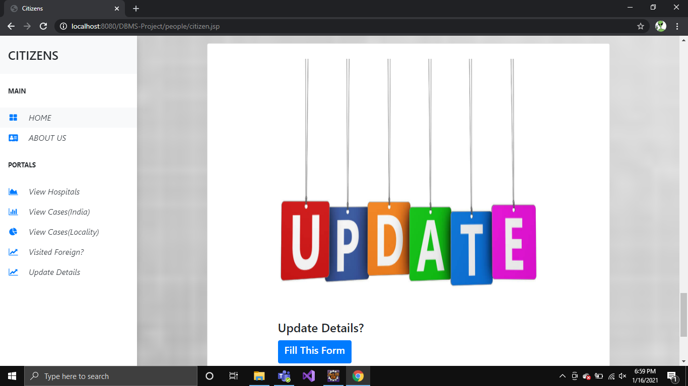

Figure 6.1.12: Update details

13. UPDATE DETAILS FORM

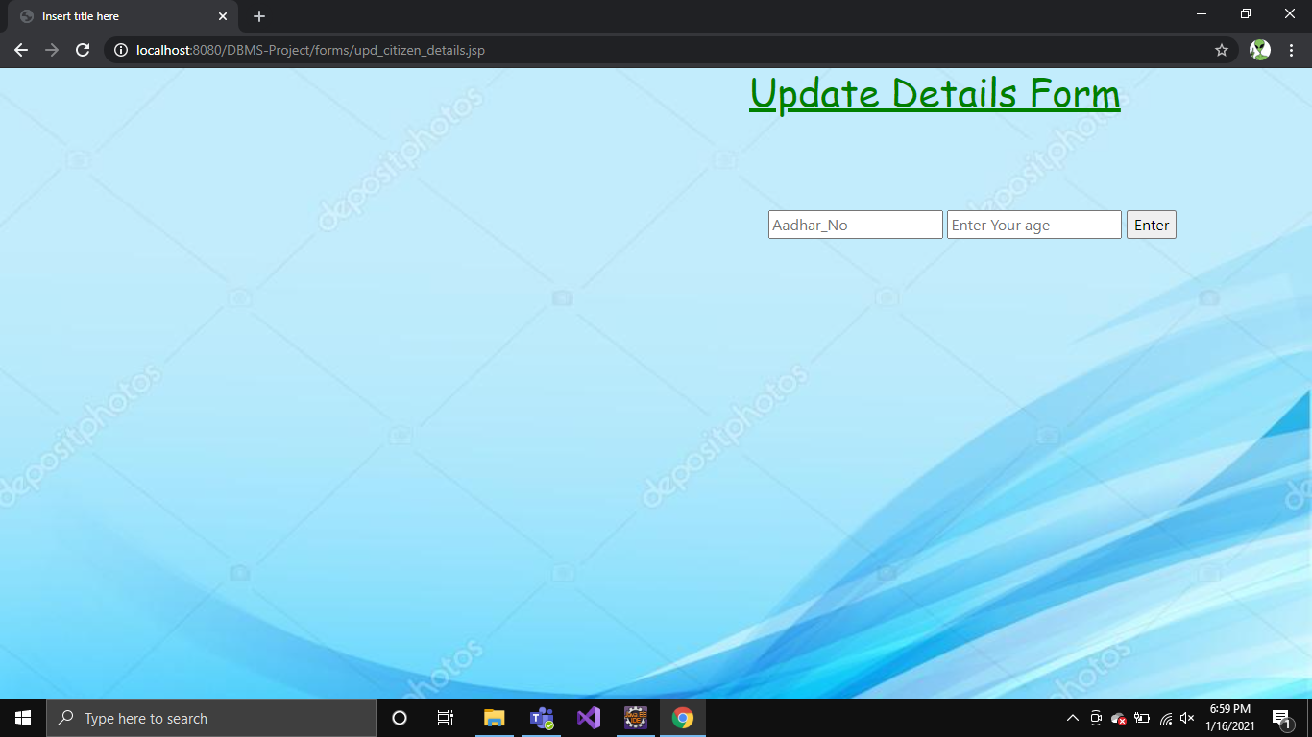

Figure 6.1.13: Update details form

14. HOSPITAL PORTAL

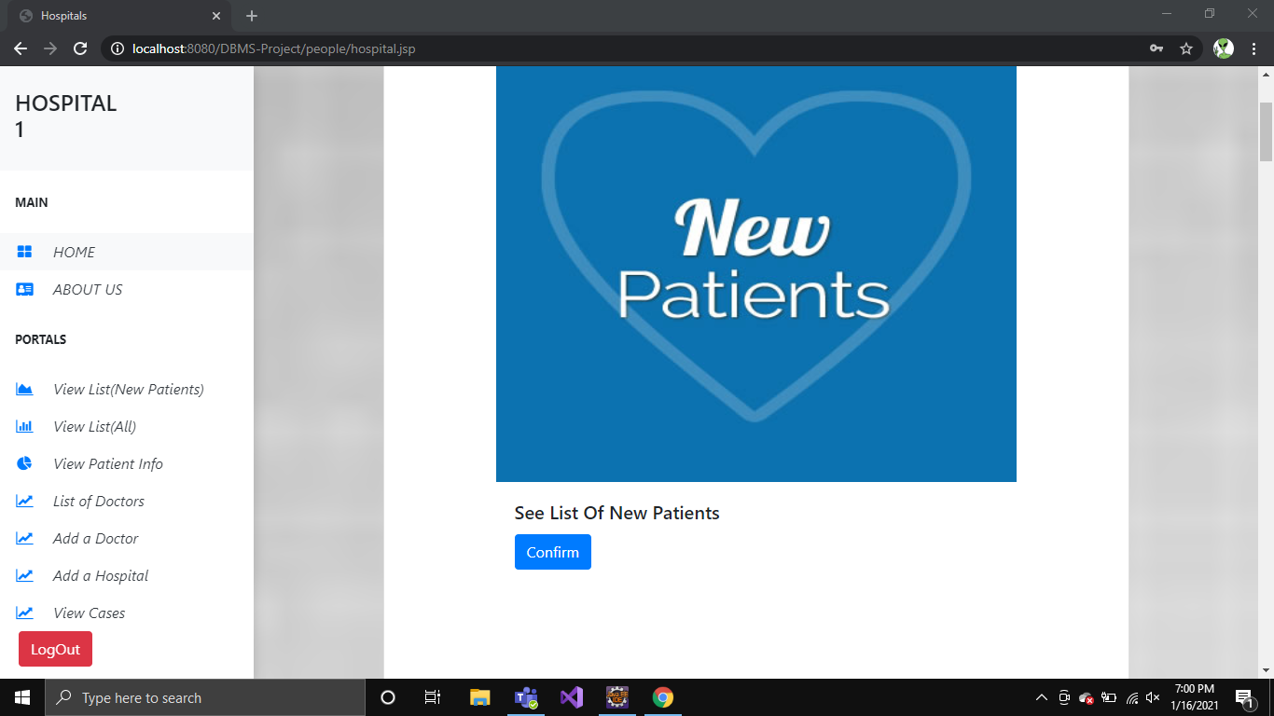

Figure 6.1.14: View new patient list

15. ASSIGN DOCTOR TO NEW PATEINT

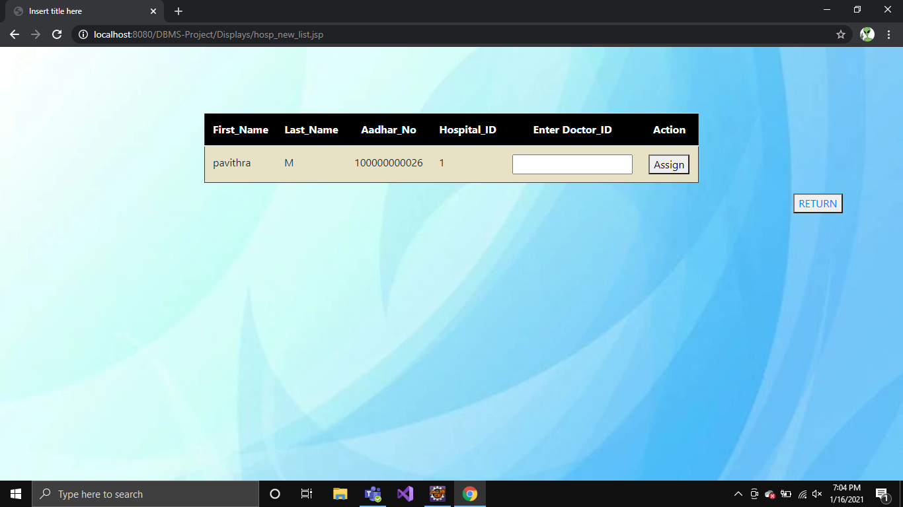

Figure 6.1.15: Assigning doctor to new patient

16. HOSPITAL PORTAL

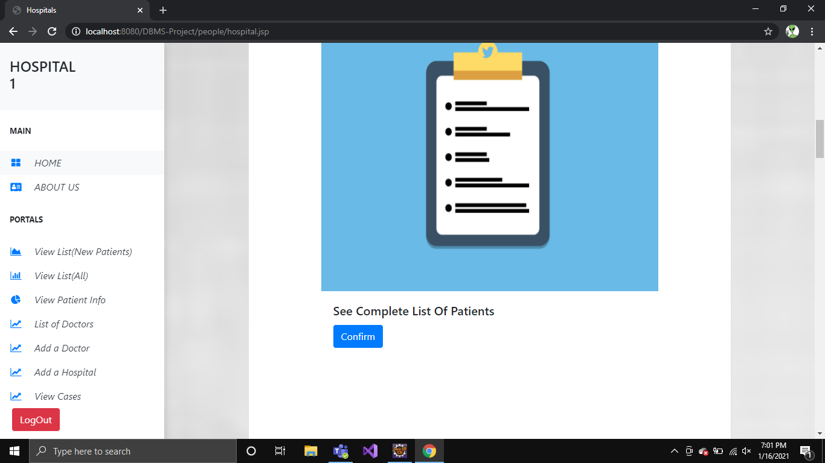

Figure 6.1.16: View complete list of patients

17. COMPLETE PATIENT LIST

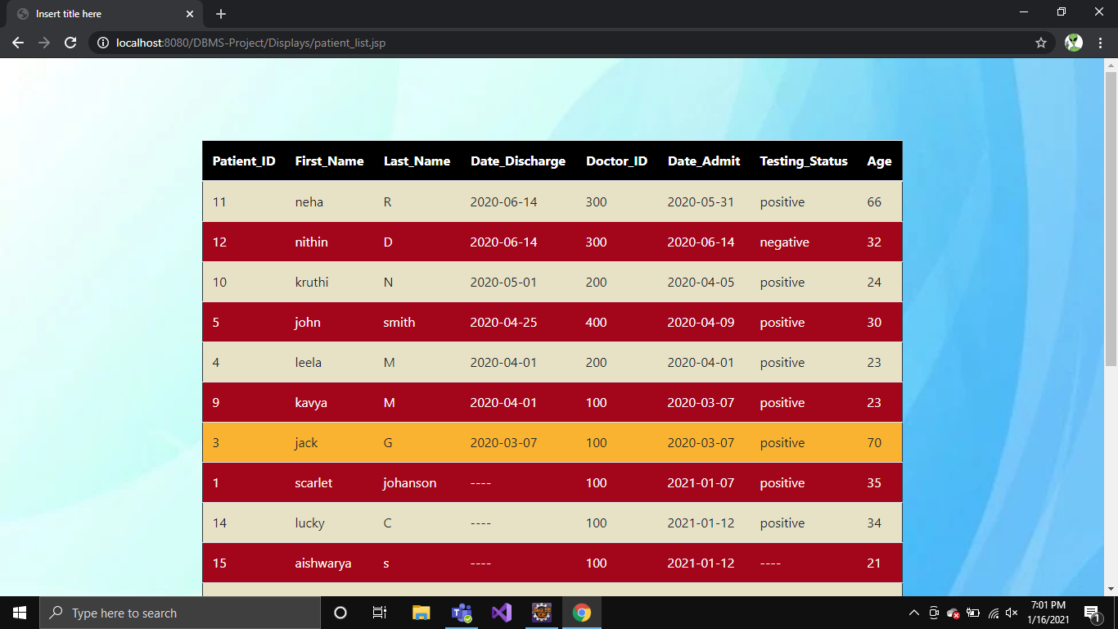

Figure 6.1.17: Complete list of patients

18. VIEW PARTICULAR PAITENT INFO

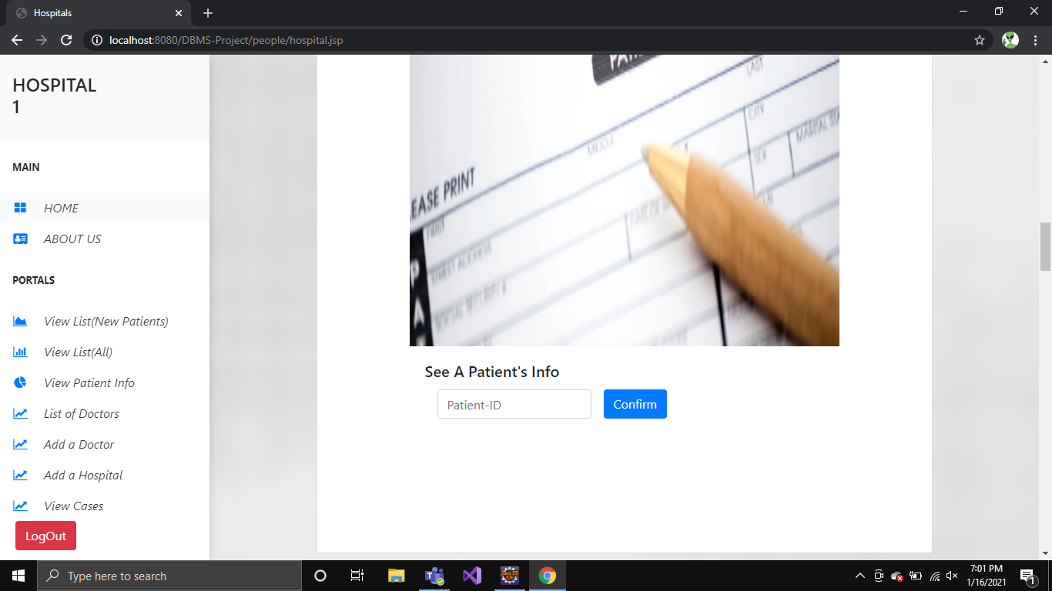

Figure 6.1.18: View particular patient info

19. PATIENT INFO

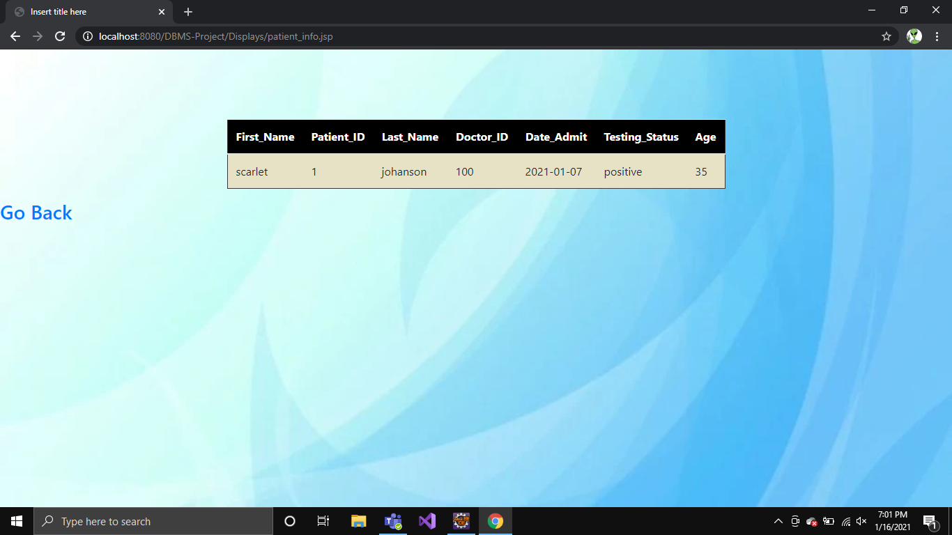

Figure 6.1.19: Individual Patient info

20. LIST OF DOCTORS

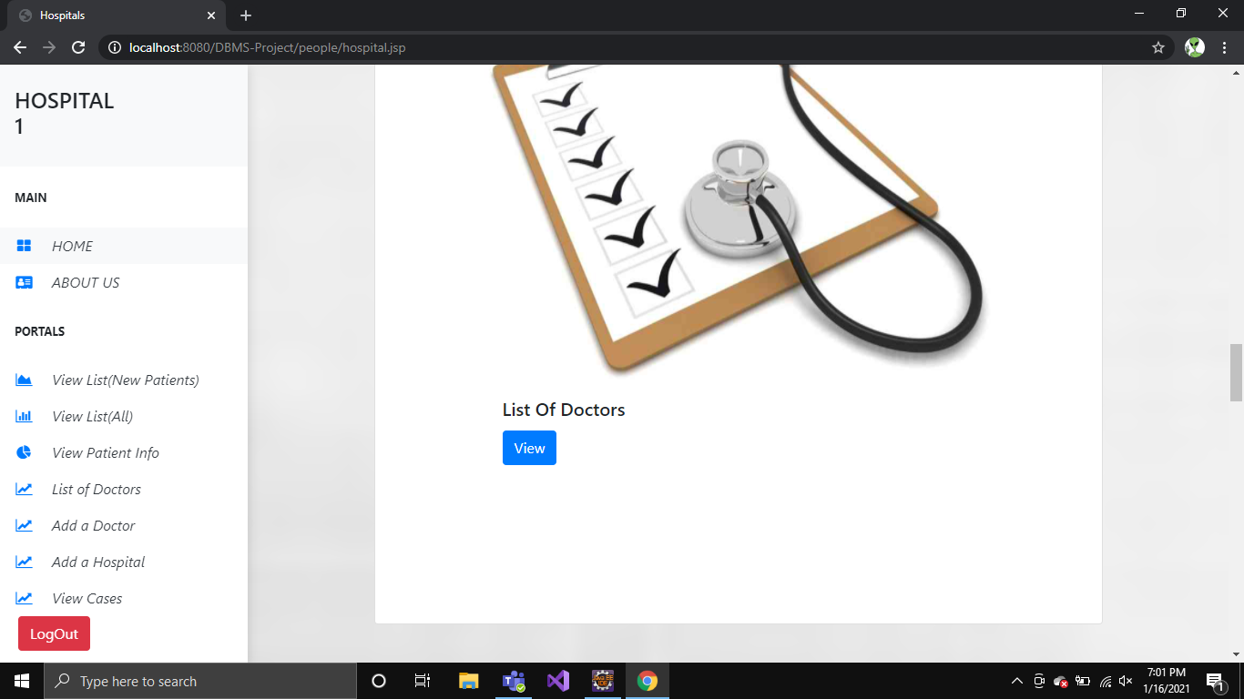

Figure 6.1.20: View list of doctors

21. DOCTOR INFO

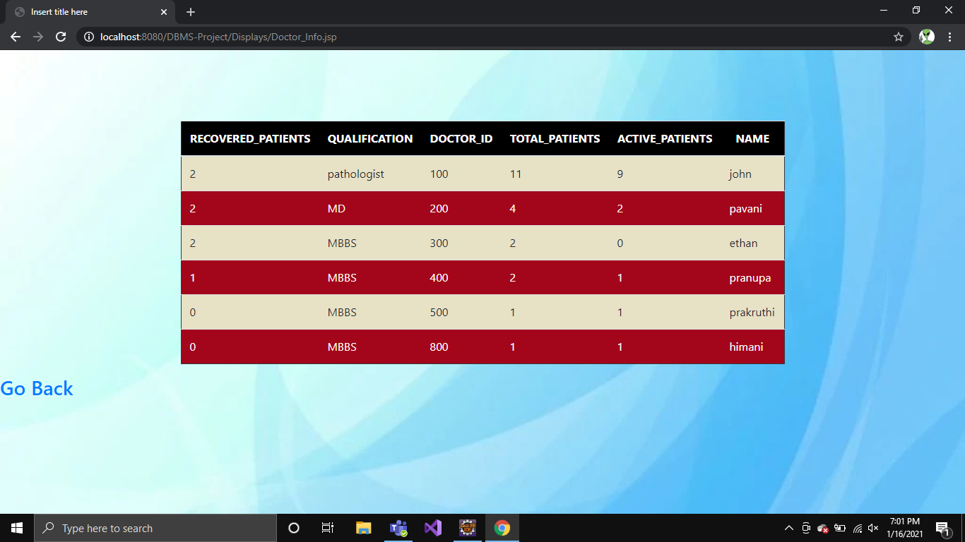

Figure 6.1.21: List of Doctor with details

22. ADD A DOCTOR

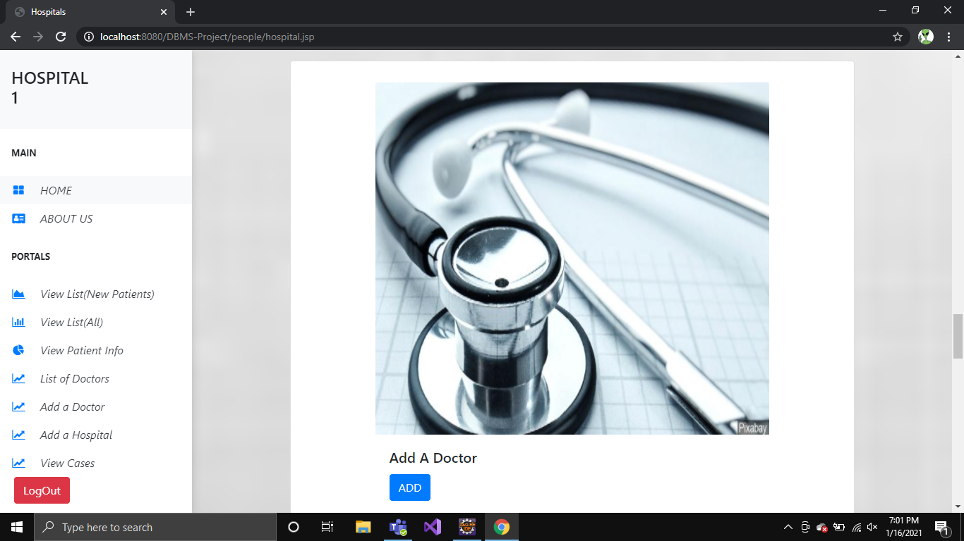

Figure 6.1.22: Add a doctor

23. PROVIDE DETAILS OF DOCTOR

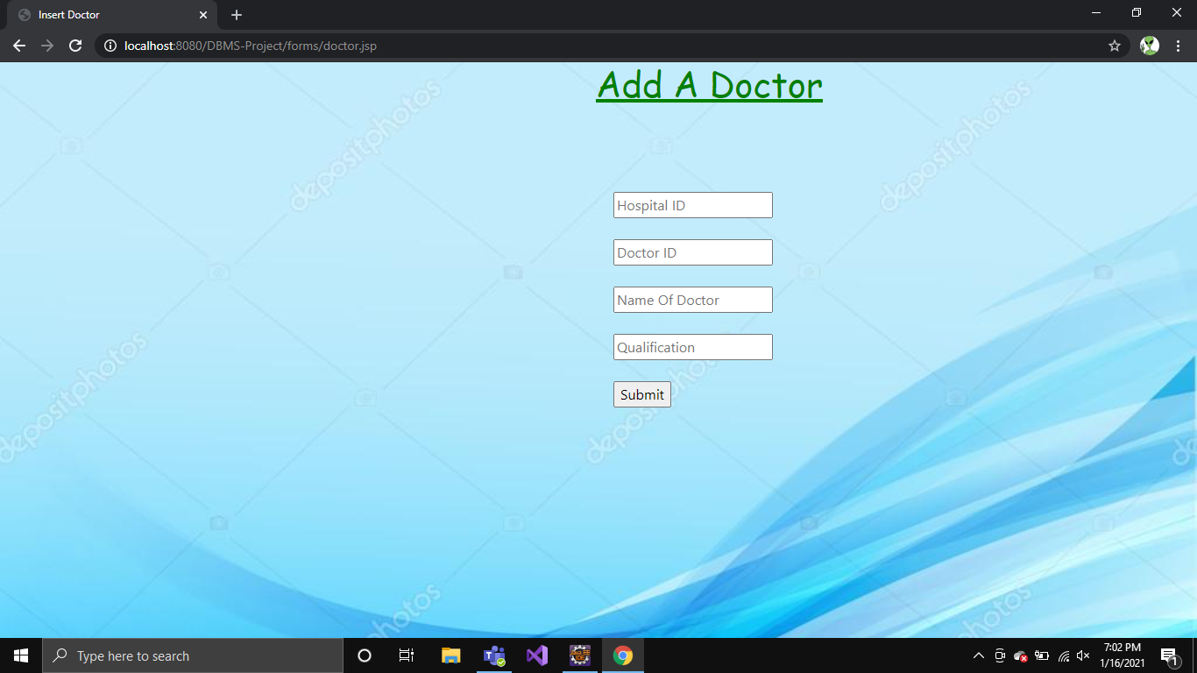

Figure 6.1.23: Provide details of doctor

24. NEW DOCTOR ADDED

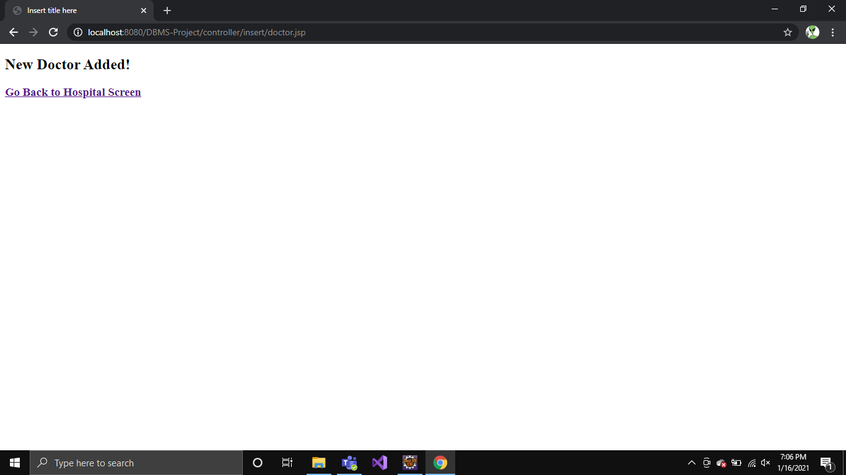

Figure 6.1.24: New doctor added

25. ADD HOSPITAL

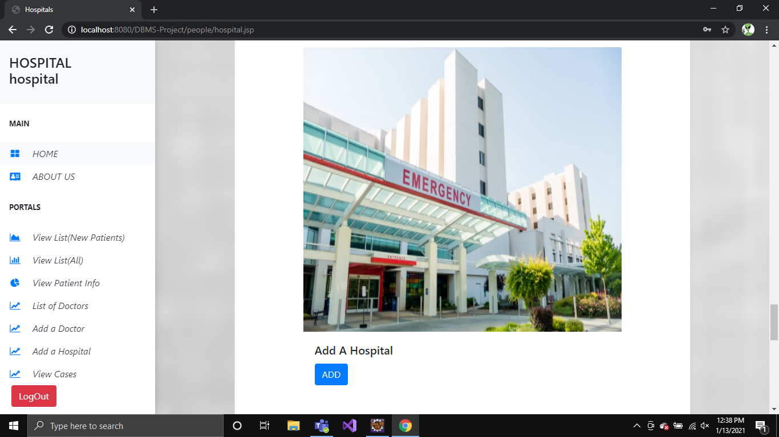

Figure 6.1.25: Add hospital

26. FILL DETAILS OF HOSPITAL

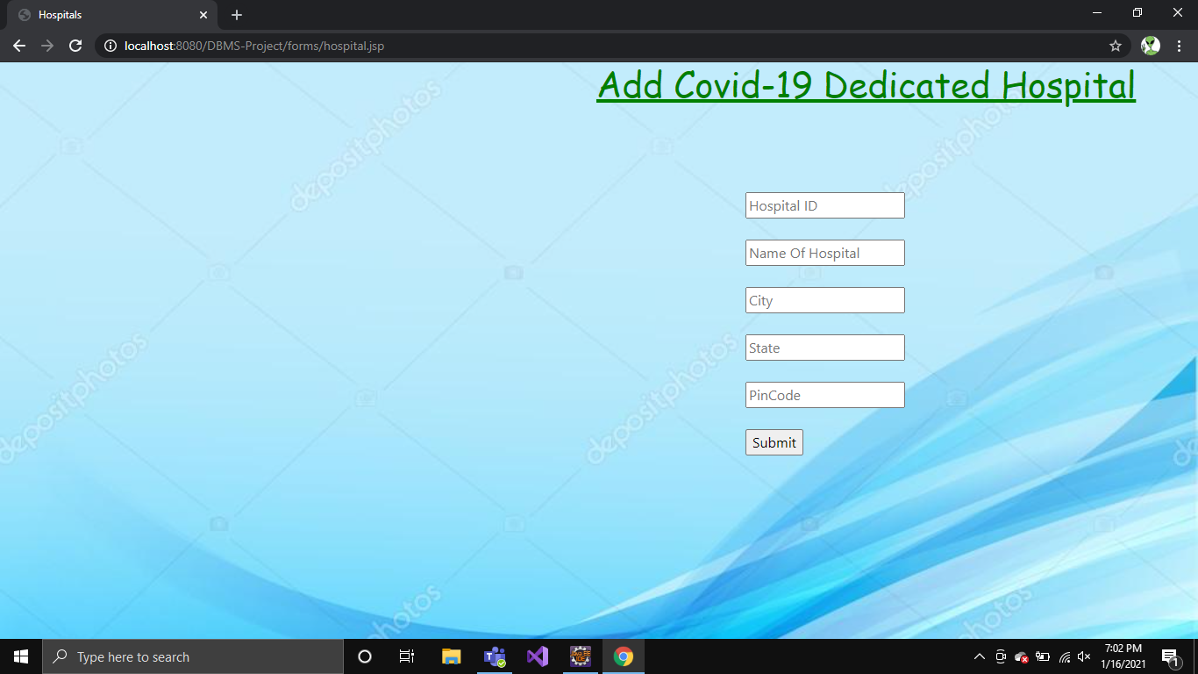

Figure 6.1.25: Enter details of hospital

27. HOSPITAL DETAILS ENTERED SUCCESSFULLY

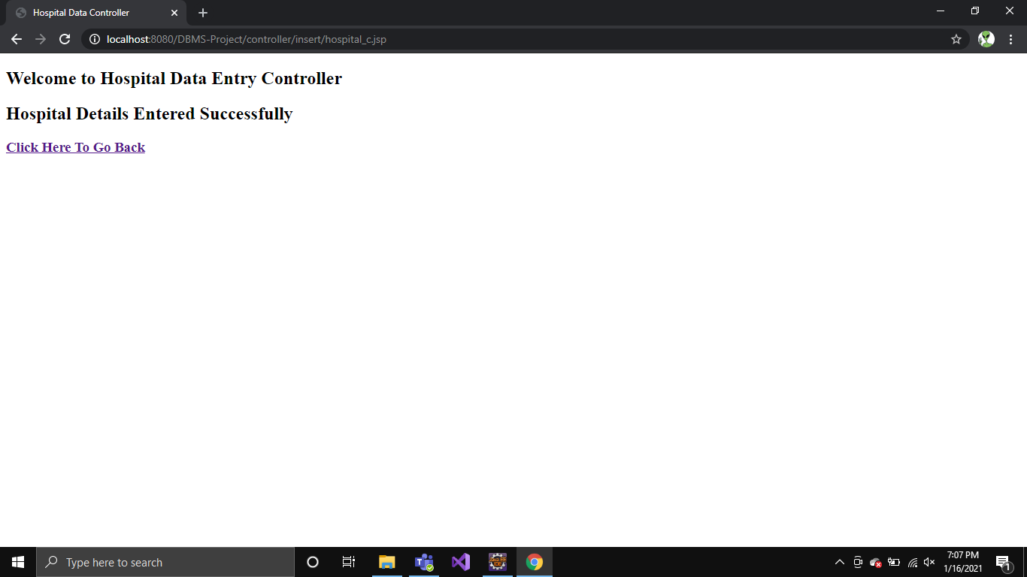

Figure 6.1.27: Hospital details entered successfully

28. ADD PATEINTS

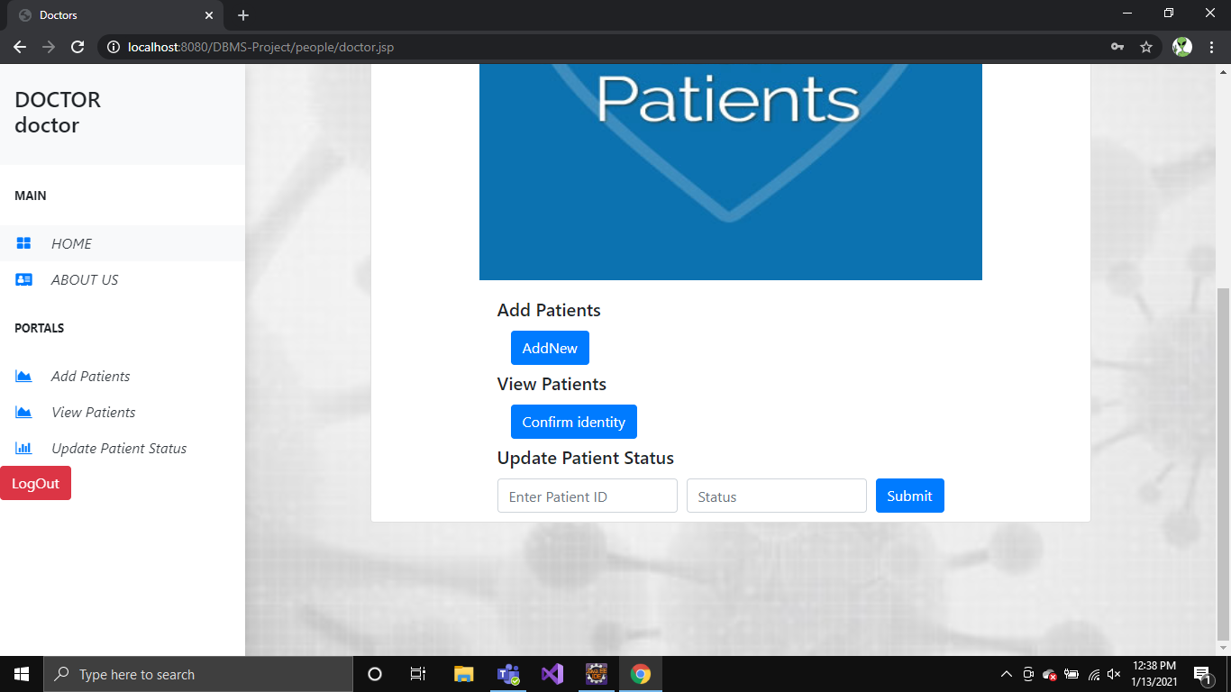

Figure 6.1.28: Add patients

29. FILL DETAILS OF PATIENT

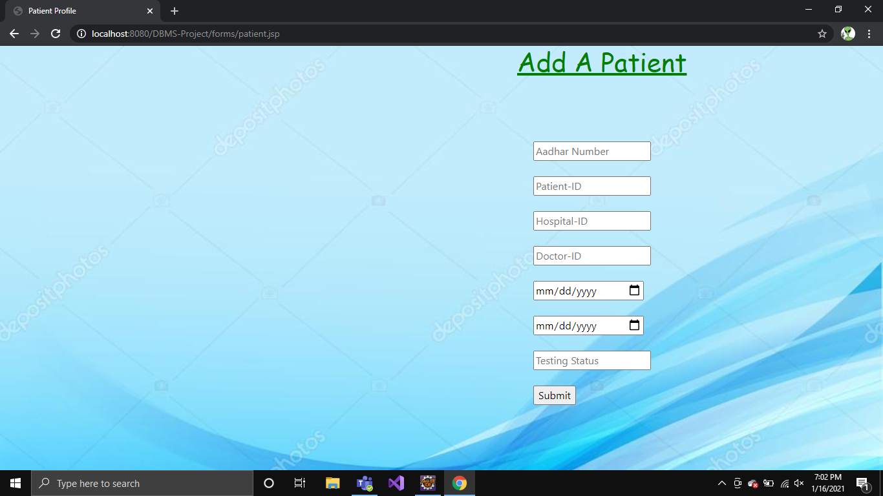

Figure 6.1.29: Enter details of patient

30. PATIENT DETAILS ENTERED SUCCESSFULLY

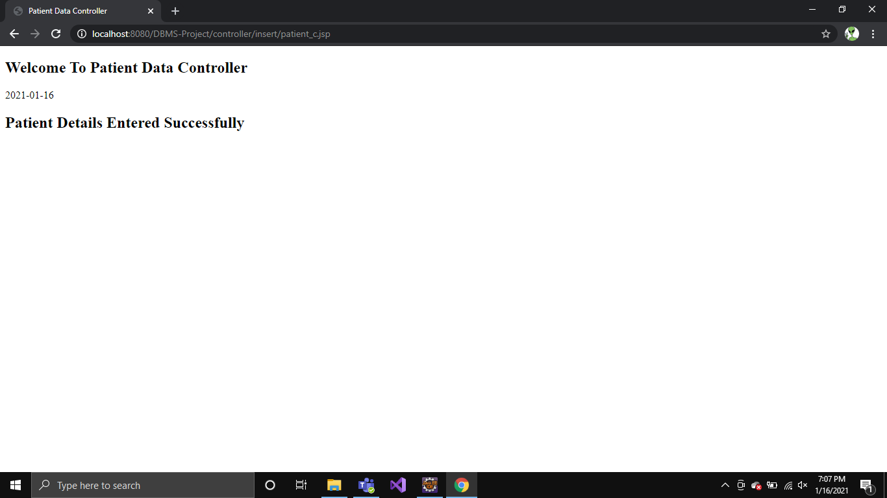

Figure 6.1.30: Patient details entered successfully

31. VIEW PATIENT LIST



Figure 6.1.31: View patient list

32. SIGN UP A PERSON

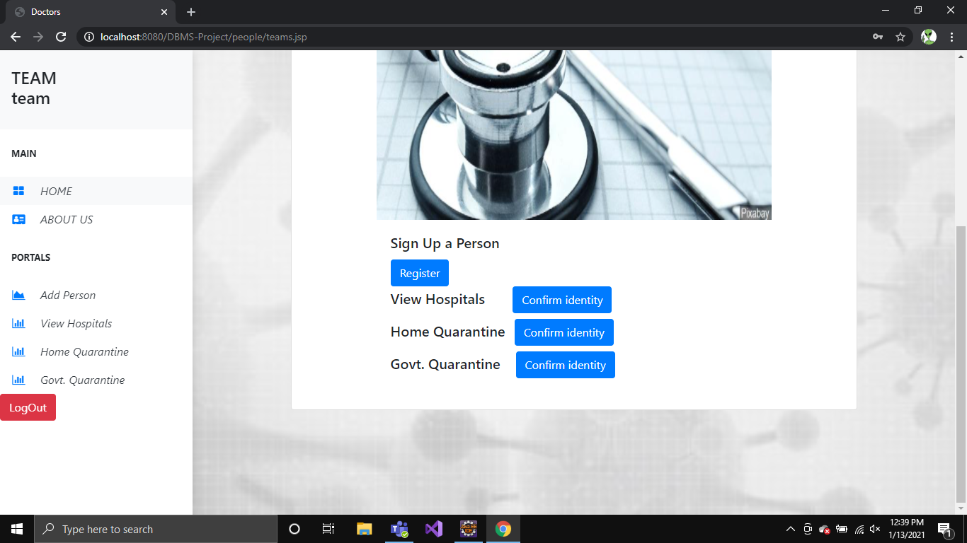

Figure 6.1.32: Register a person

33. SIGN UP PORTAL

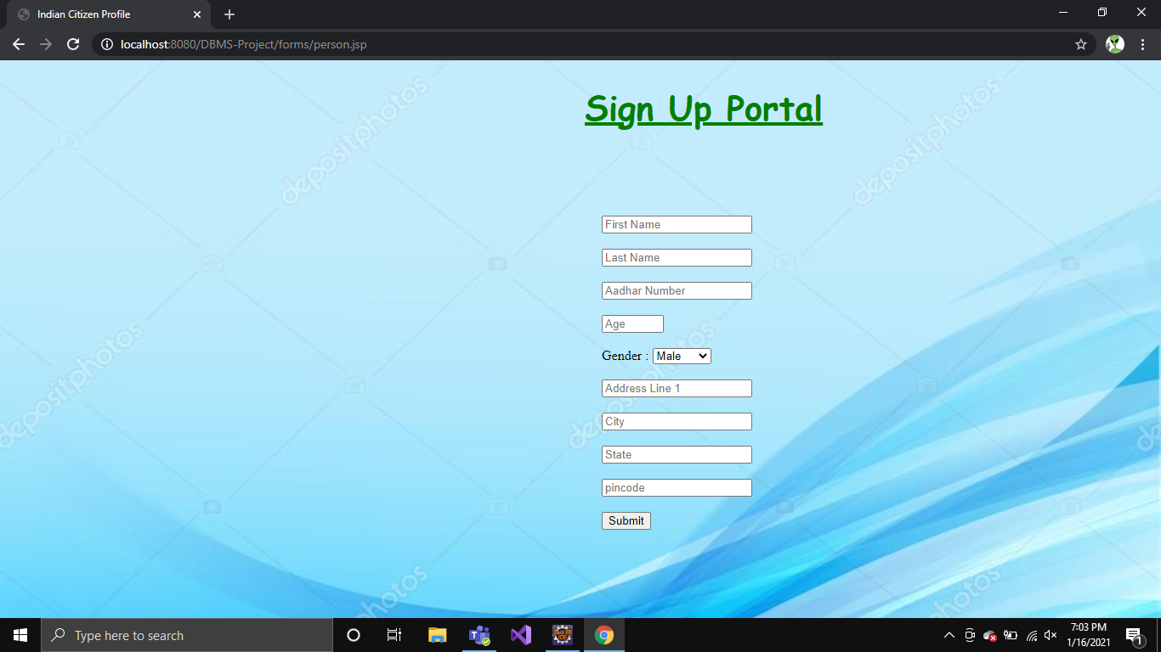

Figure 6.1.33: Sign Up portal

34. DETAILS HAVE BEEN ADDED

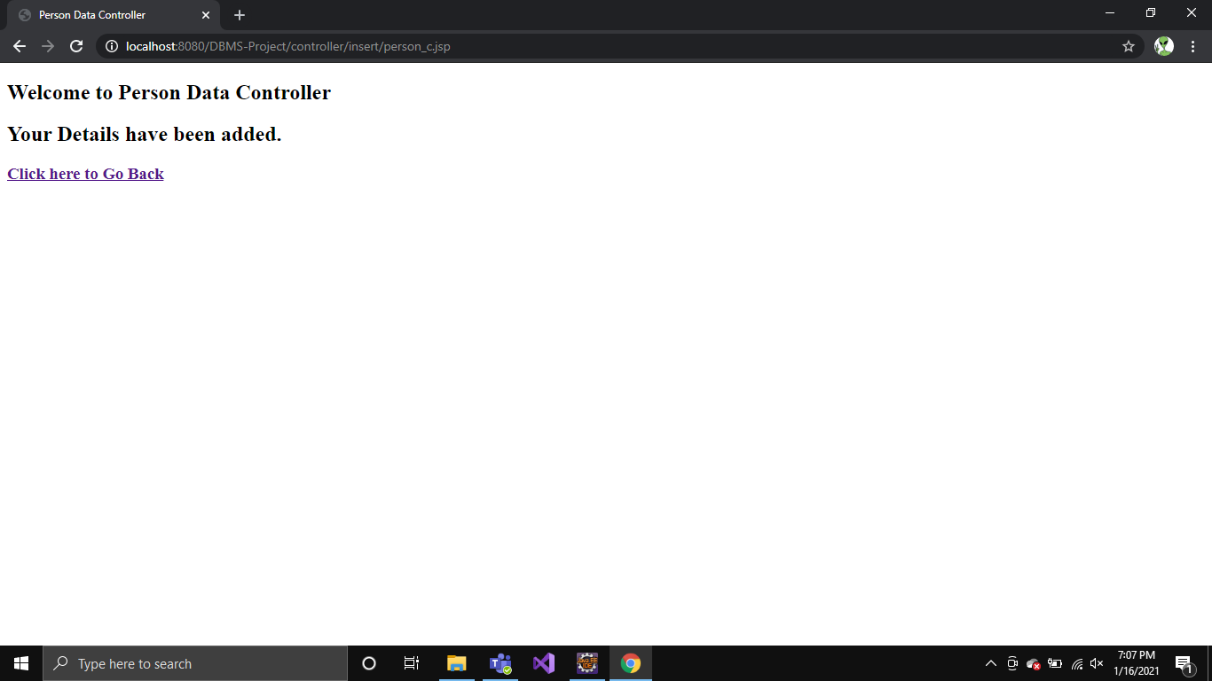

Figure 6.1.34: Details have been added

35. ADD TO GOVT QUARANTINE

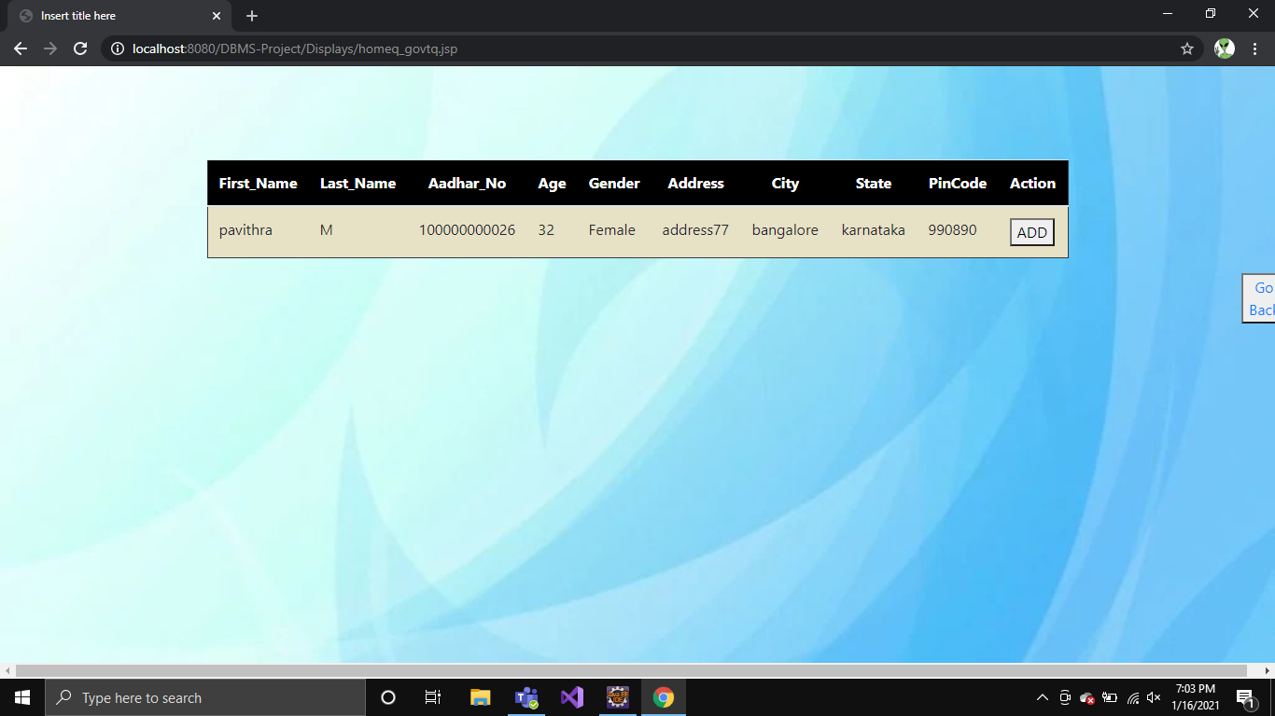

Figure 6.1.35: Add to Govt quarantine

36. SHIFTED TO GOVT QUARANTINE

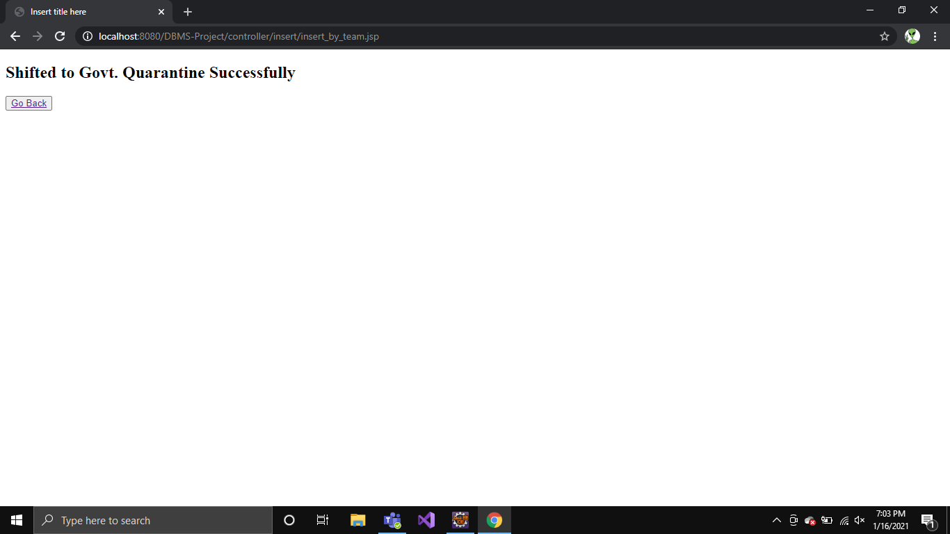

Figure 6.1.36: Shifted to Govt quarantine

37. ASSIGN HOSPITAL FOR QUARANTINE

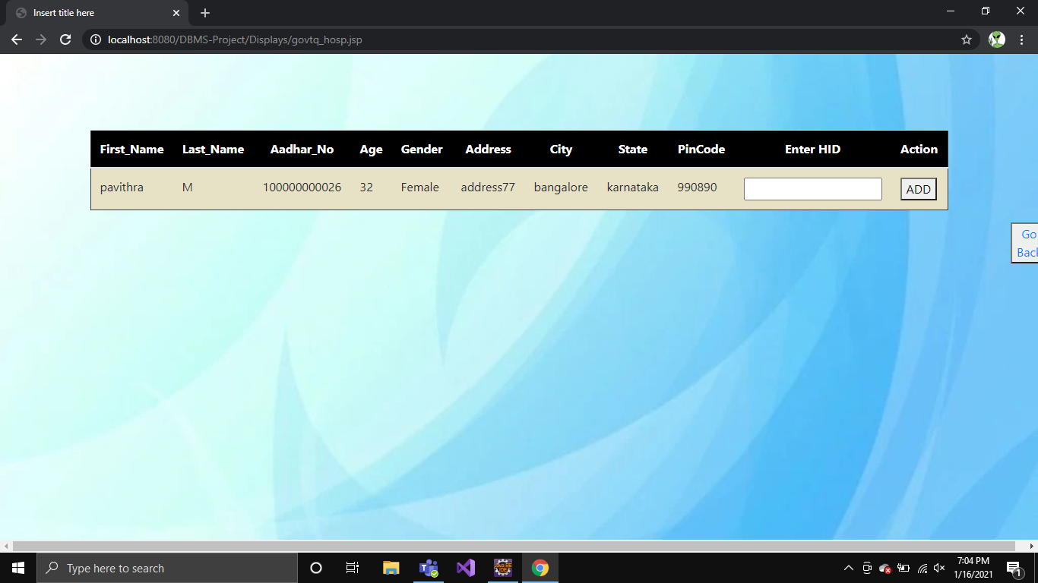

Figure 6.1.37: Assign hospital for quarantine

38. REFERRED TO HOSPITAL

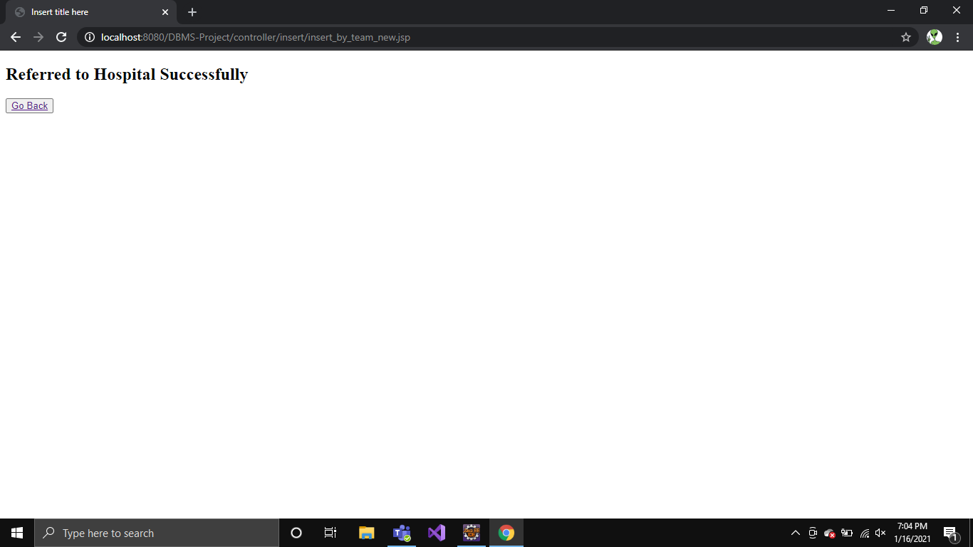

Figure 6.1.38: Referred to hospital

39. ASSIGN DOCTOR



Figure 6.1.39: Assign doctor

40. ADMIN PORTAL

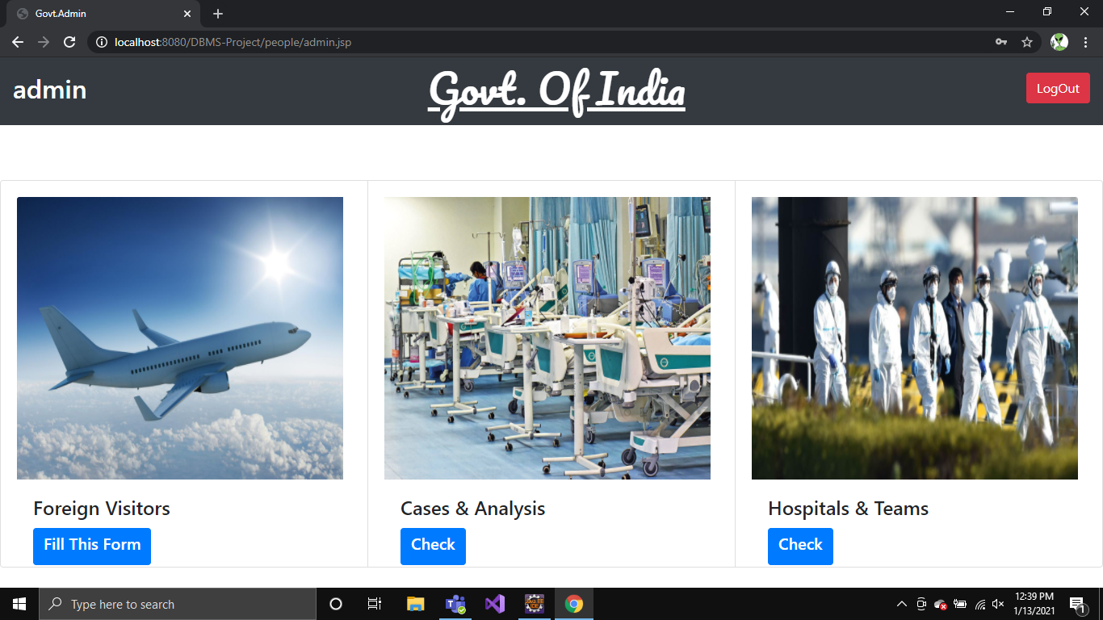

Figure 6.1.40: Admin Portal

41. HOSPITALS AND TEAMS PORTAL

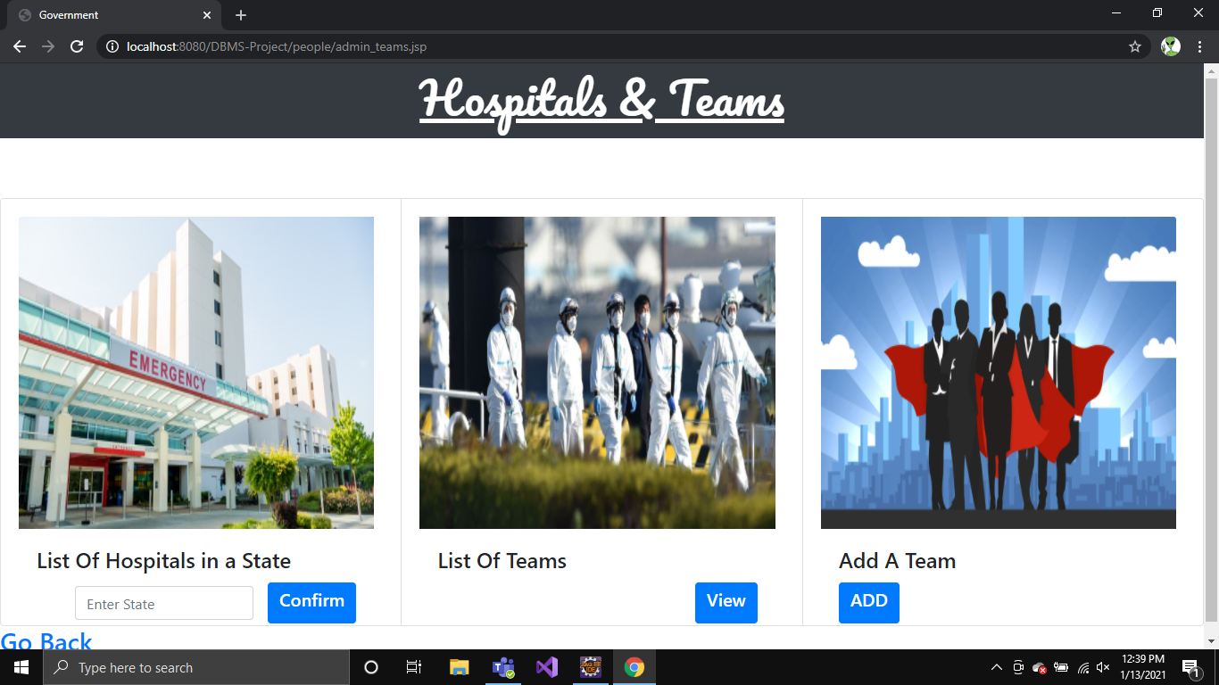

Figure 6.1.41: Hospitals and Teams portal

42. ADD TEAM

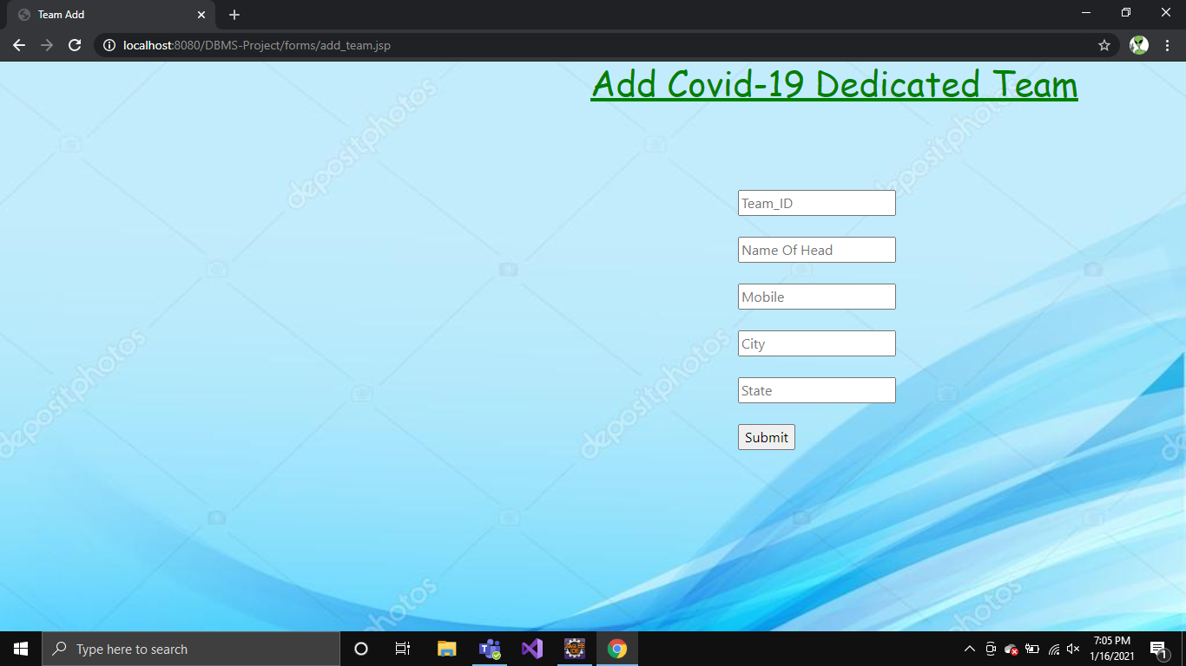

Figure 6.1.42: Add Team

43. VIEW TEAMS LIST

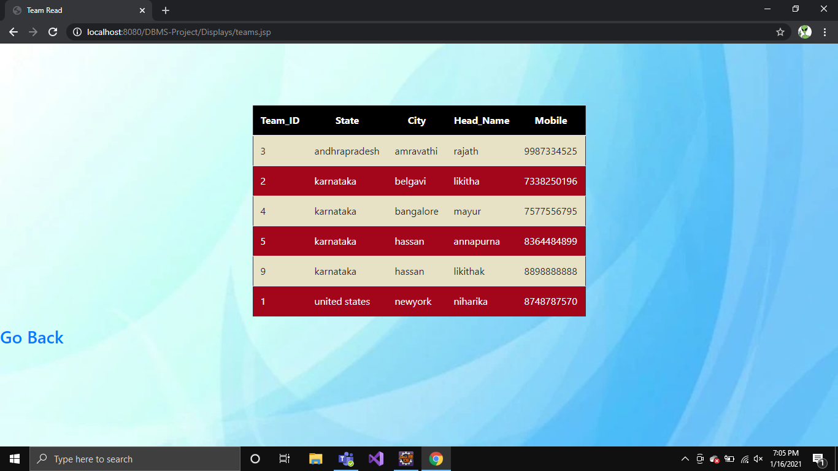

Figure 6.1.43: View Teams List

44. CASES AND ANALYSIS

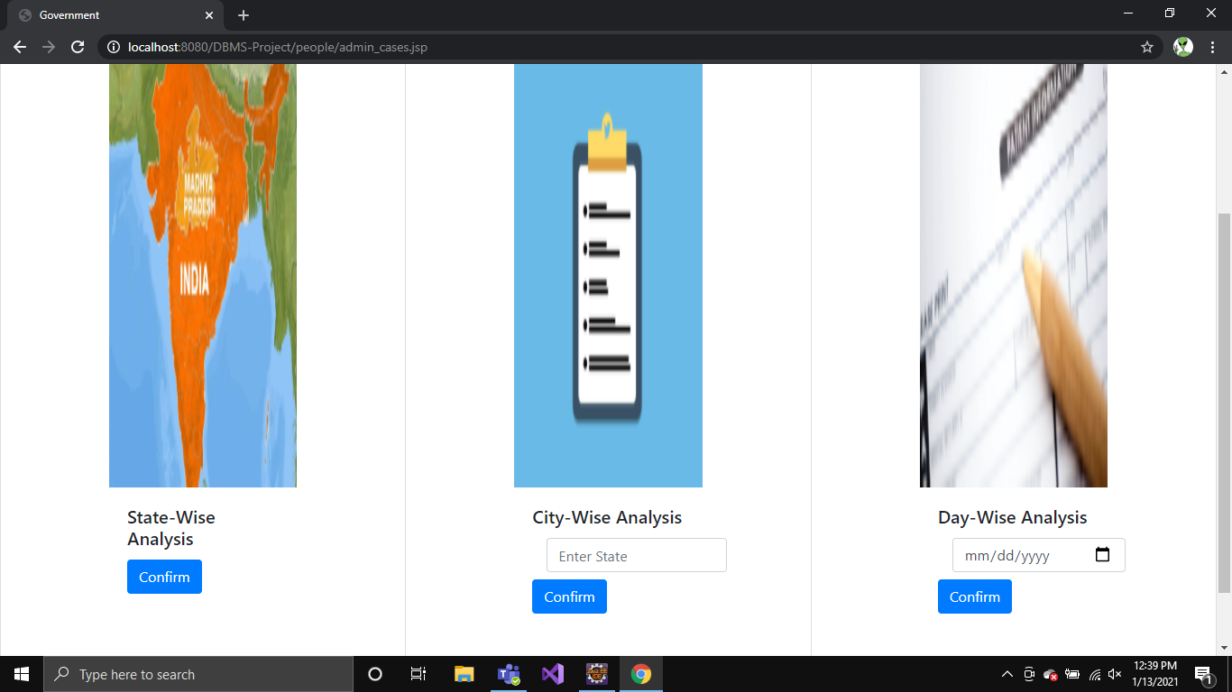

Figure 6.1.44: Cases and Analysis

45. STATE WISE ANALYSIS

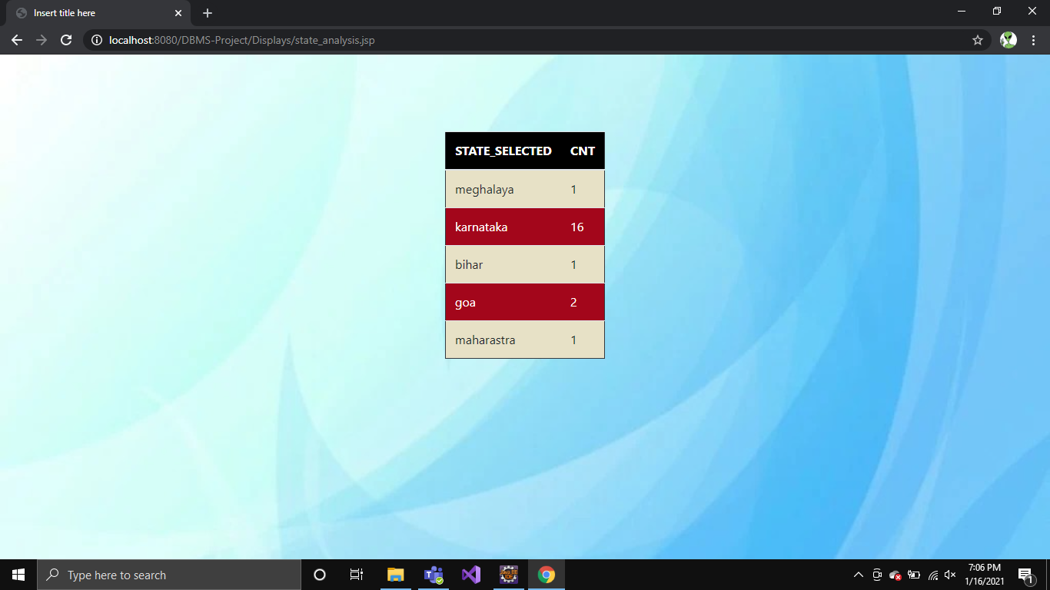

Figure 6.1.45: State-wise Analysis

46. CITY WISE ANALYSIS

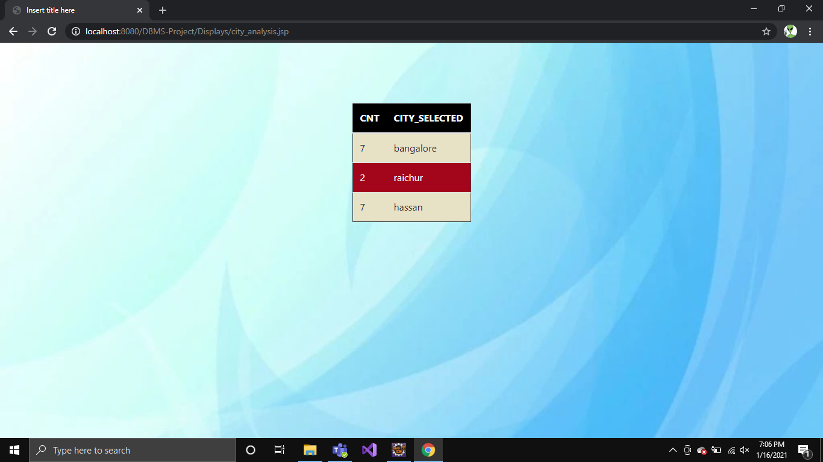 Figure 6.1.46: City-wise analysis

**6.2 Test Cases**

|  |  |  |  |  |
| --- | --- | --- | --- | --- |
| Test ID | Test Case | Input | Output | Result |
| 1 | Login | Correct Name and Password | Logged In | Successful |
| 2 | Login | In Correct Name or Password | Login Unsuccessful | Failure |
| 3 | View Hospitals In locality | Correct City Name and State | Hospital List | Successful |
| 4 | View hospital in locality | Incorrect city name or state | Enter correct credential | failure |
| 5 | Foreign visit information | Correct aadhar id and country name | Details updated successfully | successful |
| 6 | Foreign visit information | Incorrect aadhar id and country name | Enter correct aadhar id | failure |
| 7 | Update details | correct aadhar id and age | Details entered successfully | successful |
| 8 | Update details | Incorrect aadhar id | Enter valid aadhar id | failure |
| 9 | Add doctor | Correct doctor information | New doctor entered successfully | successful |
| 10 | Add doctor | Already present | Doctor already present | failure |
| 11 | Add a hospital | Correct hospital details | New hospital added | successfully |
| 12 | Add a hospital | Already present | Hospital already present | failure |
| 13 | View cases in hospital | Correct  hospital id | Display cases | successful |
| 14 | View cases in hospital | Incorrect hospital id | Enter valid hospital id | Failure |
| 15 | Add patient | Correct aadhar id and doctor id | Patient details successfully | Successfully |
| 16 | Add patient | Incorrect aadhar id or doctor id | Enter valid details | failure |
| 17 | Update patient status | Correct patient id | Patient status entered successfully | successfully |
| 18 | Update patient status | Incorrect patient id | Enter valid patient id | failure |
| 19 | Signup a person | Correct person details | Patient details entered successfully | successful |
| 20 | Signup a person | Incorrect person details | Enter valid patient details | failure |
| 21 | Add a team | Correct details | New team added | successful |
| 22 | Add a team | Incorrect details | Enter valid information | Failure |
| 23 | List of hospitals in a state | Correct state name | List of hospitals in the state | Successful |
| 24 | List of hospitals in a state | Incorrect state name | Enter correct state name | Failure |
| 25 | City wise analysis | Correct state name | Display cases in each city | Successful |
| 26 | logout |  |  |  |

**CHAPTER-7**

**APPLICATIONS**

**APPLICATIONS**

**7.1 APPLICATIONS**

* The webpage can be used by health organizations and also the government to track and store data related to Covid-19 cases.
* The hospitals can effectively manage the doctors treating their patients.
* The application can be used to monitor the home quarantined and government quarantined people.
* The doctors can follow their patient’s status flexibly.
* It provides an effective system to store data related to COVID-19 patients which is essential for researchers, medical organizations and authorities.

**CHAPTER-8**

**CONCLUSION**

**CONCLUSION**

**8.1 CONCLUSION**

This project aims in developing an organized system to keep the data regarding COVID-19 patients in check. If this application is deployed in large scale it is very helpful for all the countries across the world to track the data.

The stored and collected data can be later used by analysts and scientists to conduct experiments.